**CRM Application for EduConsultPro Institute**

**OVERVIEW**

EduConsultPro Institute, a renowned educational institution, provides a broad range of courses and programs across various disciplines. Each year, the institute receives a large volume of inquiries and applications from prospective students, which poses an increasing challenge for the admissions and consulting departments to manage efficiently. To enhance operational efficiency and ensure a positive experience for students, EduConsultPro has opted to implement Salesforce CRM, a powerful platform known for streamlining complex business processes and improving customer relationship management.

**OBJECTIVE**

This project aims to develop a comprehensive CRM solution that addresses the core needs of EduConsultPro's admissions process. By leveraging Salesforce, the CRM application will enhance the end-to-end admission process, from initial student inquiries to final admission decisions. Additionally, it will support case management, allowing the admissions team to handle prospective students’ inquiries and consulting requests efficiently. This system will provide a structured, transparent, and seamless experience for students, while also empowering the admissions team to optimize workflows, reducing bottlenecks and manual tasks.

**FEATURES AND FUNCTIONALITIES**

* Student Inquiry Management: Capture and track student inquiries in a centralized system. The CRM will enable the admissions team to respond quickly, follow up, and offer detailed information about programs, courses, and requirements.
* Admission Application Processing: Provide a smooth workflow for processing admission applications, with automated assignment, tracking, and notifications for both staff and students. This feature will ensure timely updates and reduce application processing times.
* Case Management: Enable admissions staff to efficiently manage student inquiries and consulting requests as cases, tracking their status, priority, and resolution within Salesforce. This will improve response times and ensure that each case is managed properly from start to finish.
* Consulting Services: Integrate consulting service requests into the CRM, allowing prospective students to seek expert guidance on course selection, career paths, and application procedures. Staff can then respond to and manage these requests in one place.

**MileStone 1 - Salesforce**

**Introduction**

Are you new to Salesforce? Not sure exactly what it is, or how to use it? Don’t know where you should start on your learning journey? If you’ve answered yes to any of these questions, then you’re in the right place. This module is for you.

[Welcome to Salesforce! Salesforce is game-changing technology, with a host of productivity-boostin](https://youtu.be/r9EX3lGde5k)g features, [that will help you sell smarter and faster. As you work toward your badge for this module, we’ll take](https://youtu.be/r9EX3lGde5k) you through [these features and answer the question, “What is Salesforce, anyway?”.](https://youtu.be/r9EX3lGde5k)

**What is salesforce?**

Salesforce is your customer success platform, designed to help you sell, service, market, analyze , and connect with your customers. Salesforce has everything you need to run your business from anywhere. Using standard products and features, you can manage relationships with prospects and customers, collaborate and engage with employees and partners, and store your data securely in the cloud.

So what does that really mean? Well, before Salesforce, your contacts, emails, follow-up tasks, and prospective deals might have been organized something like this.



**Activity 1 - Creating a Developer Profile**

To start using Salesforce, the first step is to create a developer org Follow the steps below to create your Salesforce Developer Account

**Go to the Signup Page**

* Navigate to the Salesforce Developer Signup page: Salesforce Developer Profile.

**Fill up the Signup Form**

* **First Name :** Nikhitha Siva Durga
* **Last Name :** Yerra
* **Email :** 21jg1a1236.nikhitha@gvpcew.ac.in
* **Company :** Gayatri vidya parishad college of engineering for women
* **Country :** India
* **Postal Code :** 530048
* **Username :** 21jg1a1236.nikhitha@gvpcew.ac.in

**Submit the Form**

* After filling in the details, click on the "Sign me up" button

You have successfully created a Salesforce Developer Account. You will receive a confirmation email with further instructions to complete the setup.

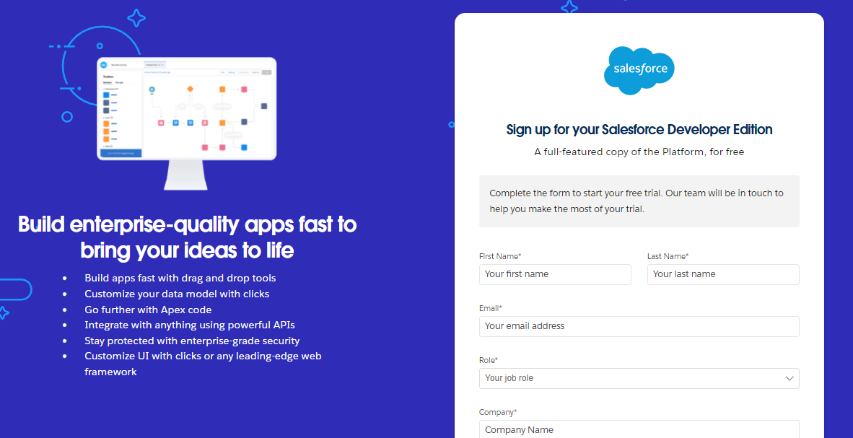

**Activity 2 - Account Activation**

After creating your Salesforce Developer Account, you need to activate it. Follow these steps to activate your account

* Go to the inbox of the email that you used while signing up. Click on the verify account to activate your account. The email may take 5-10mins.

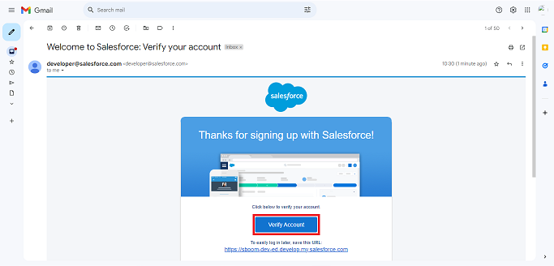

* Click on Verify Account
* Give a password and answer a security question and click on change password.
* Then you will redirect to your salesforce setup page.

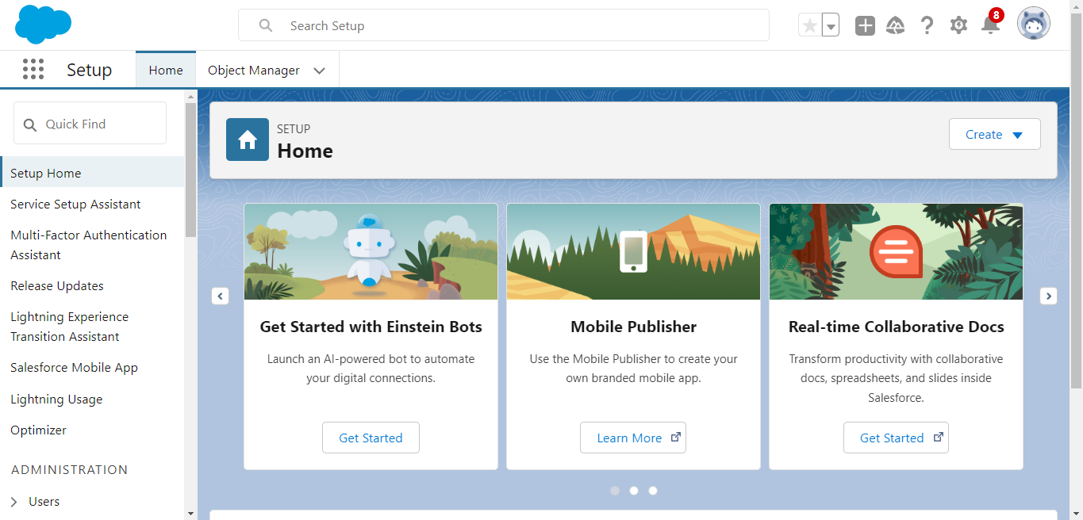

**MileStone 2 - Object**

**What Is an Object?**

Salesforce objects are database tables that permit you to store data that is specific to an organization. What are the types of Salesforce objects

Salesforce objects are of two types:

1. **Standard Objects:** Standard objects are the kind of objects that are provided by salesforce.com such as users, contracts, reports, dashboards, etc.
2. **Custom Objects:** Custom objects are those objects that are created by users. They supply information that is unique and essential to their organization. They are the heart of any application and provide a structure for sharing data.

To Navigate to Setup page:

* Click on gear icon.
* click setup.

To Create an Object:

* From the setup page, click on Object Manager
* Click on Create
* Click on Custom Object from spreadsheet
* Then log in to your account
* Click on upload , then select the required spreadsheet
* Enter the Label, plural label and API Name for the object and finish
* The object is created

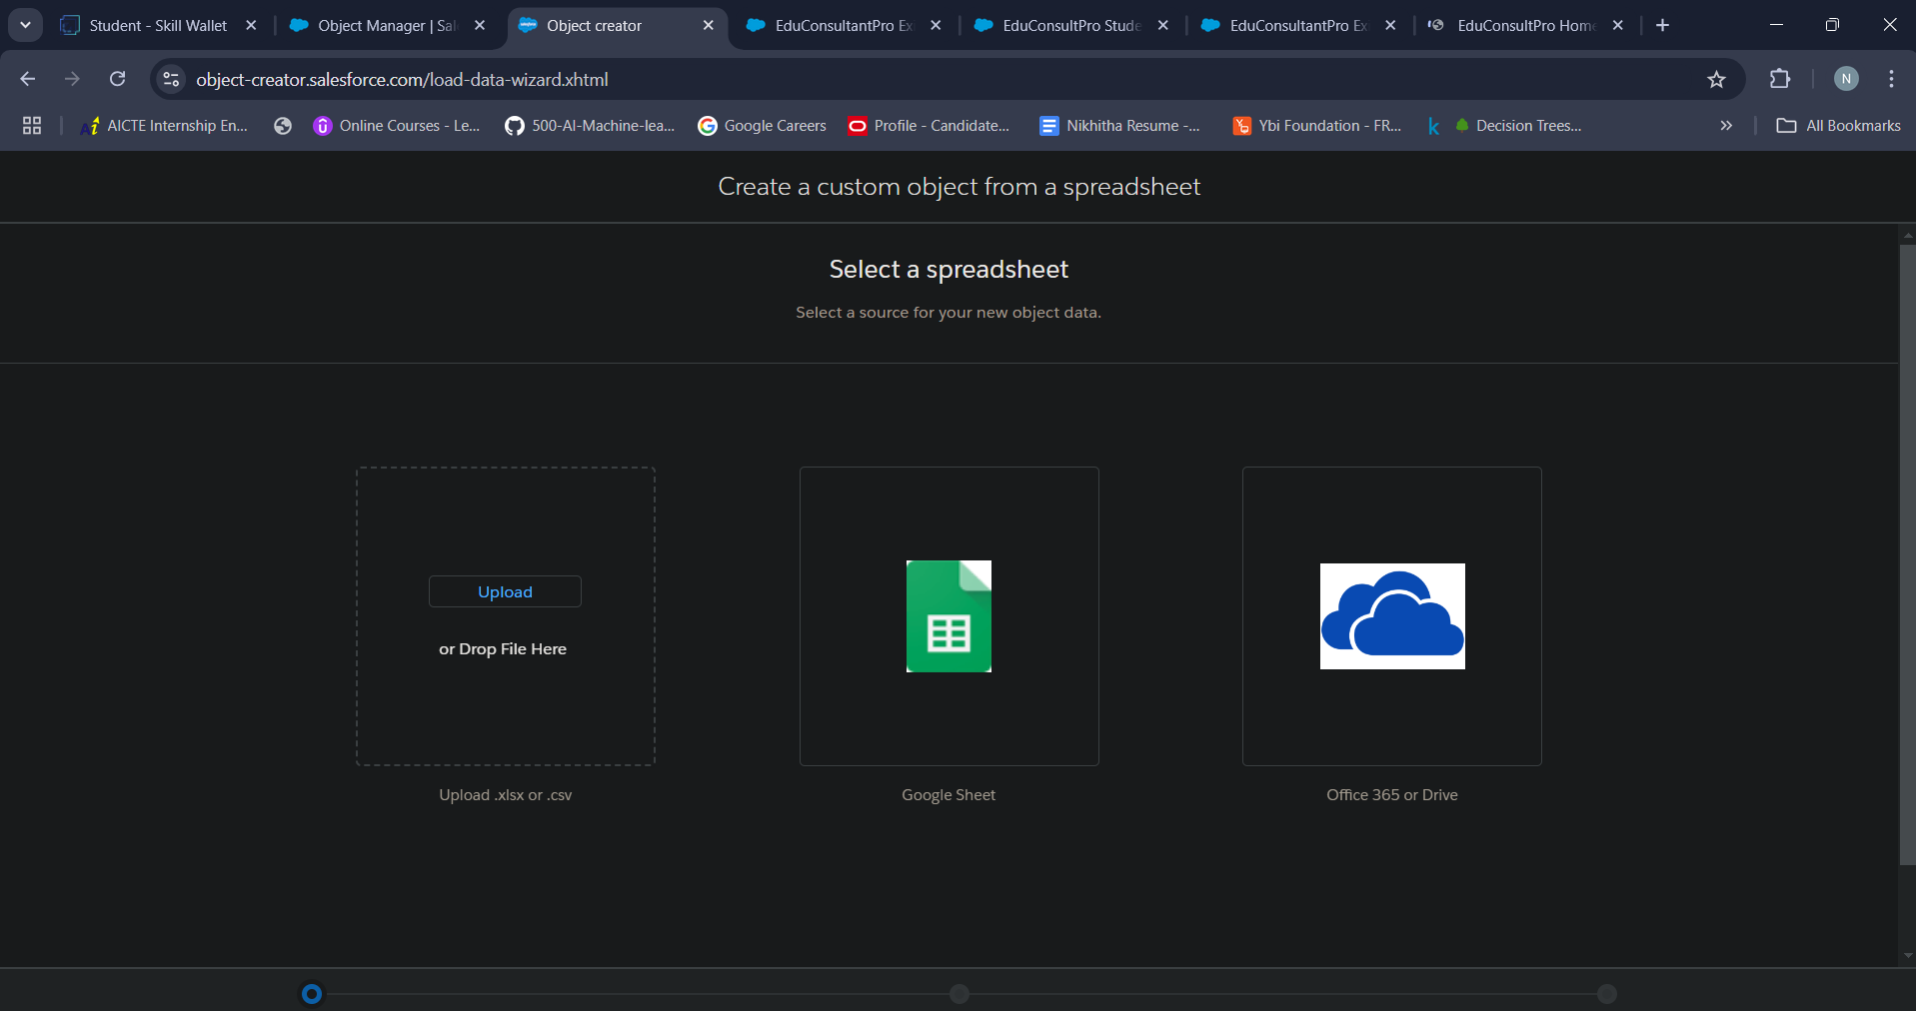

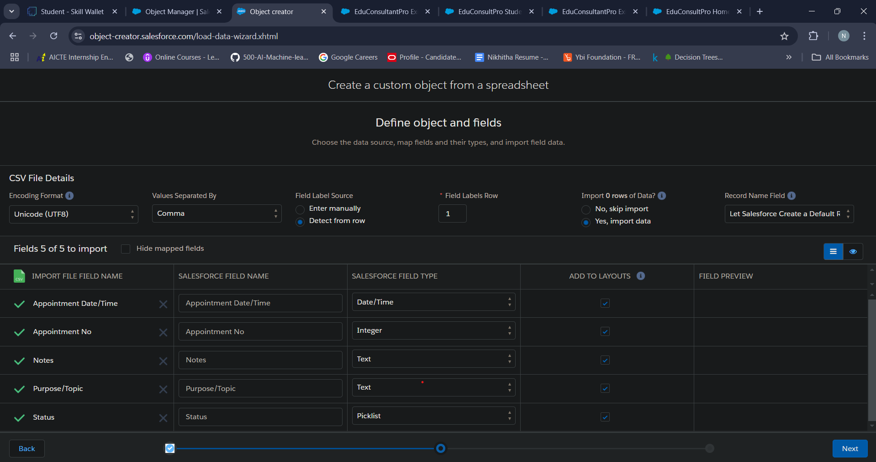

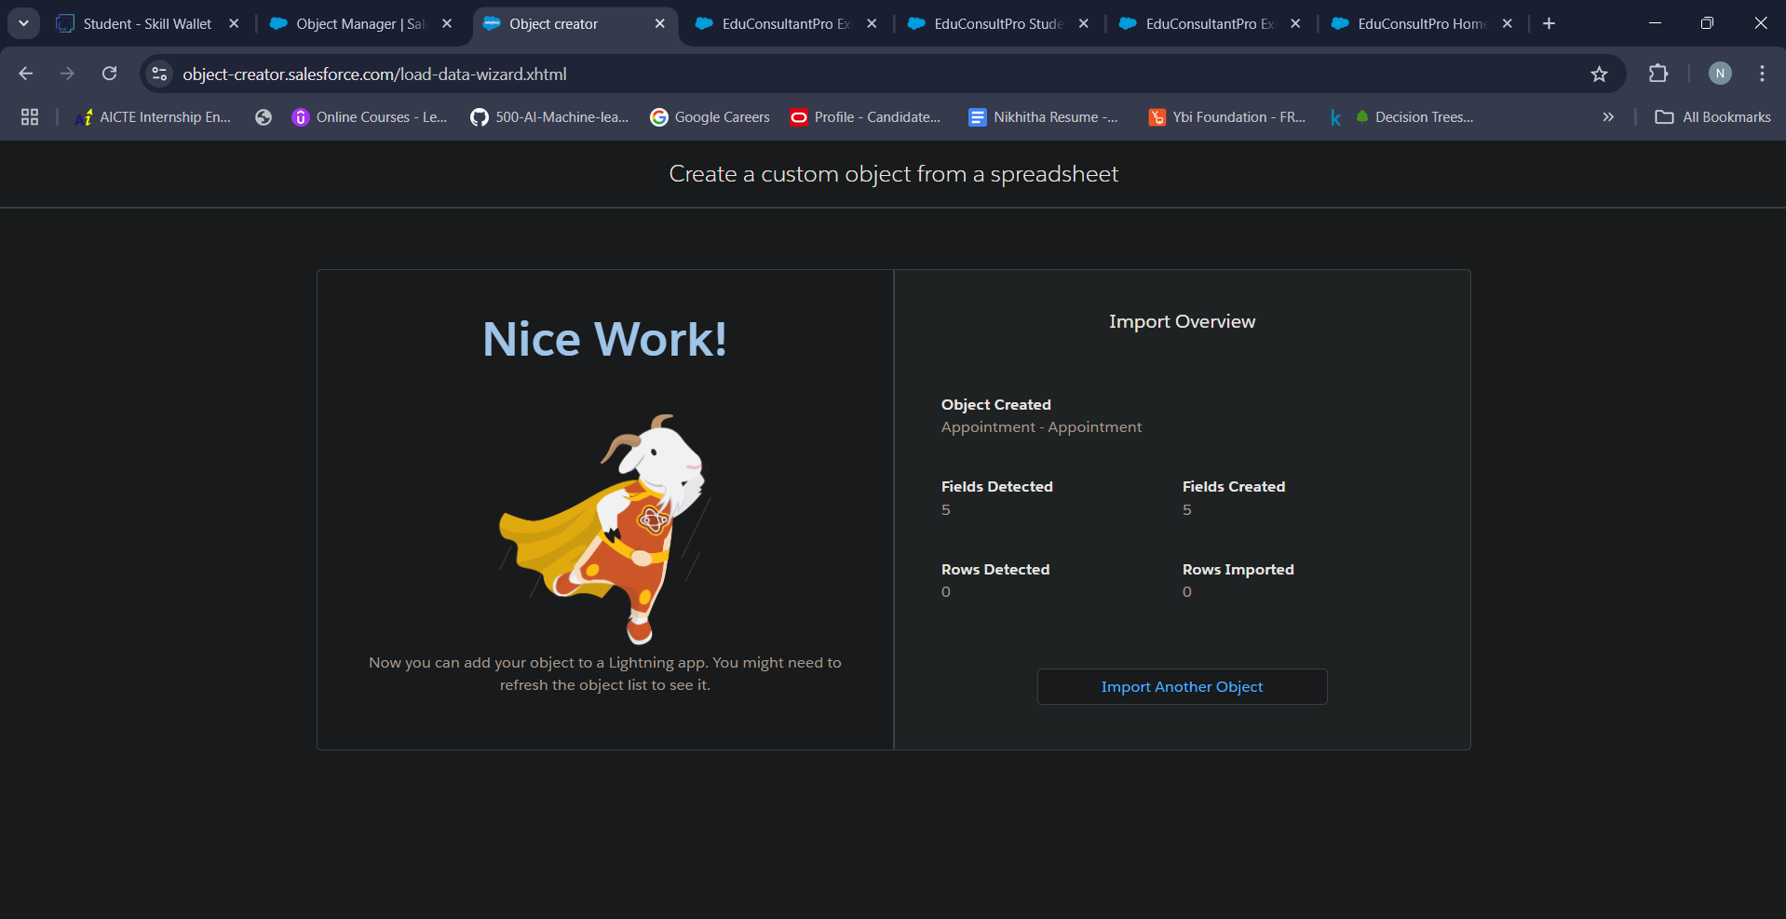

**Activity 1 - Create Course, Appointment, Consultant, Student objects**

To create a Course object in Salesforce, follow these steps

**Navigate to Setup Page:**

* Click on the gear icon
* Click on Setup.

**Create & Custom Object from spreedsheet:**

* From the setup page, click on Object Manager
* Click on Create
* Click on Custom Object from spreadsheet

**Define the Custon Object:**

* Enter the Label Name: Course.
* Enter the Plural Label Name Courses. Enter the Record Name Label and Format
* Data Type: Text
* Change the labels and follow the same steps for student, consultant, appointment

**Save the Custom Object:**

* Click on Save

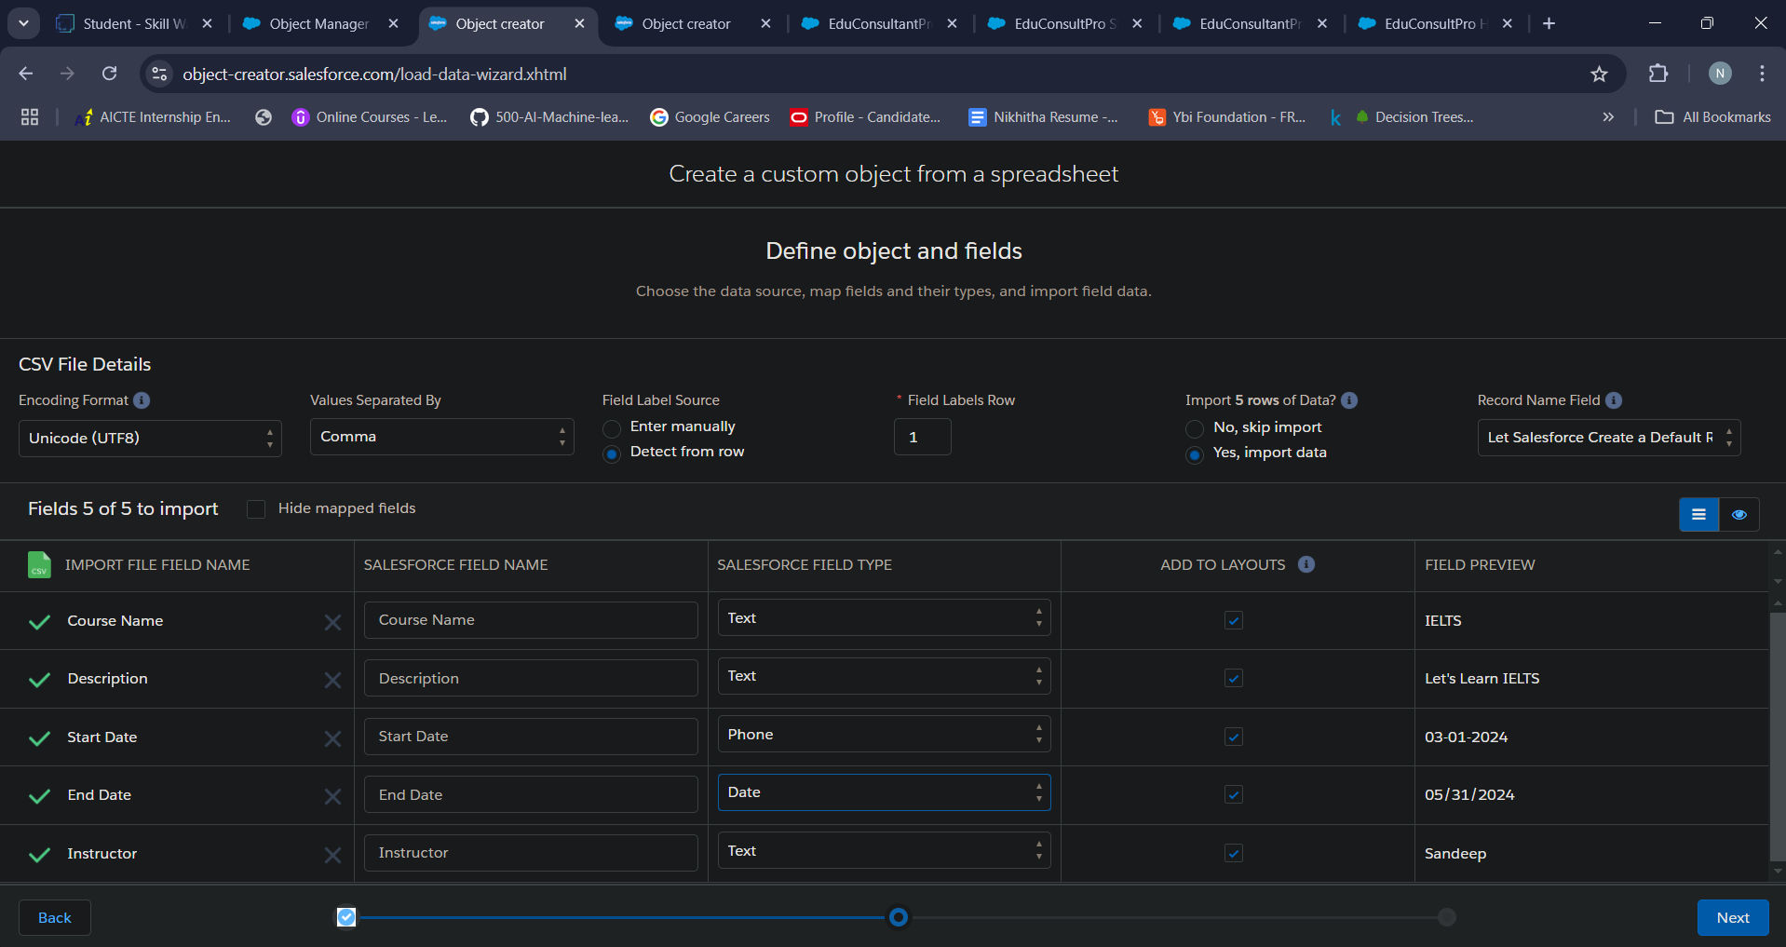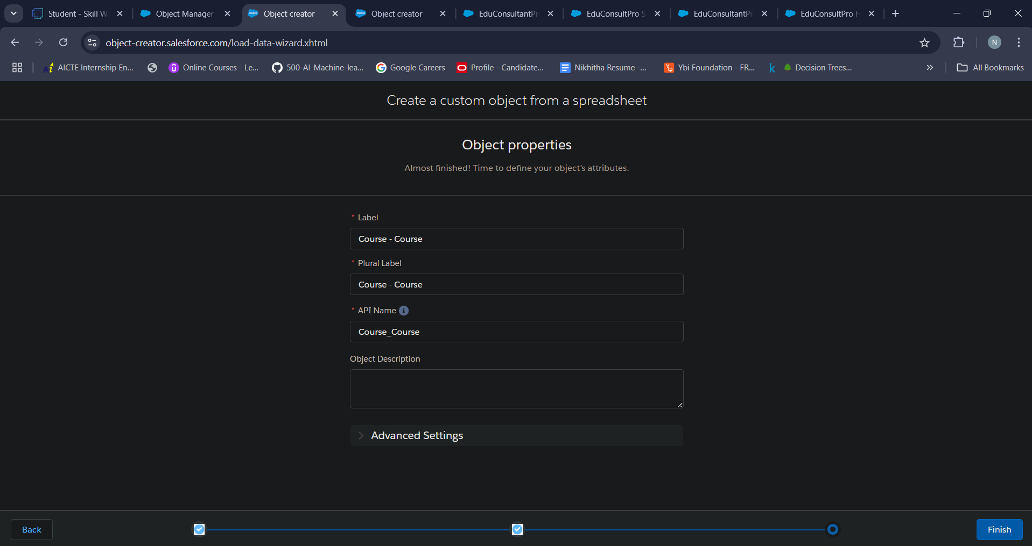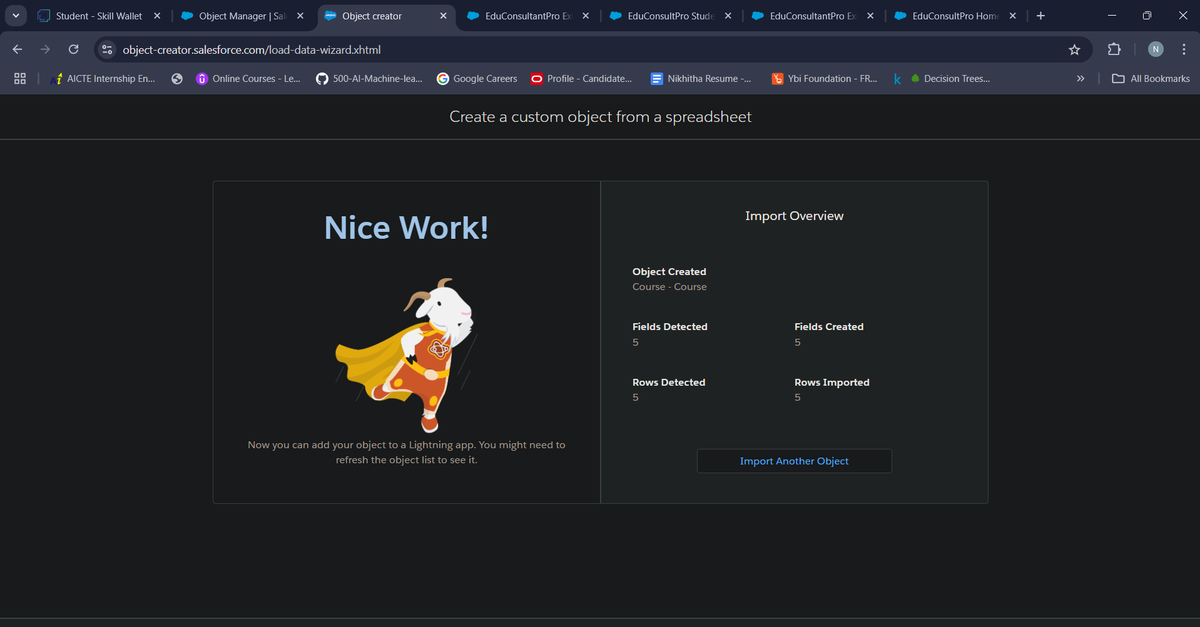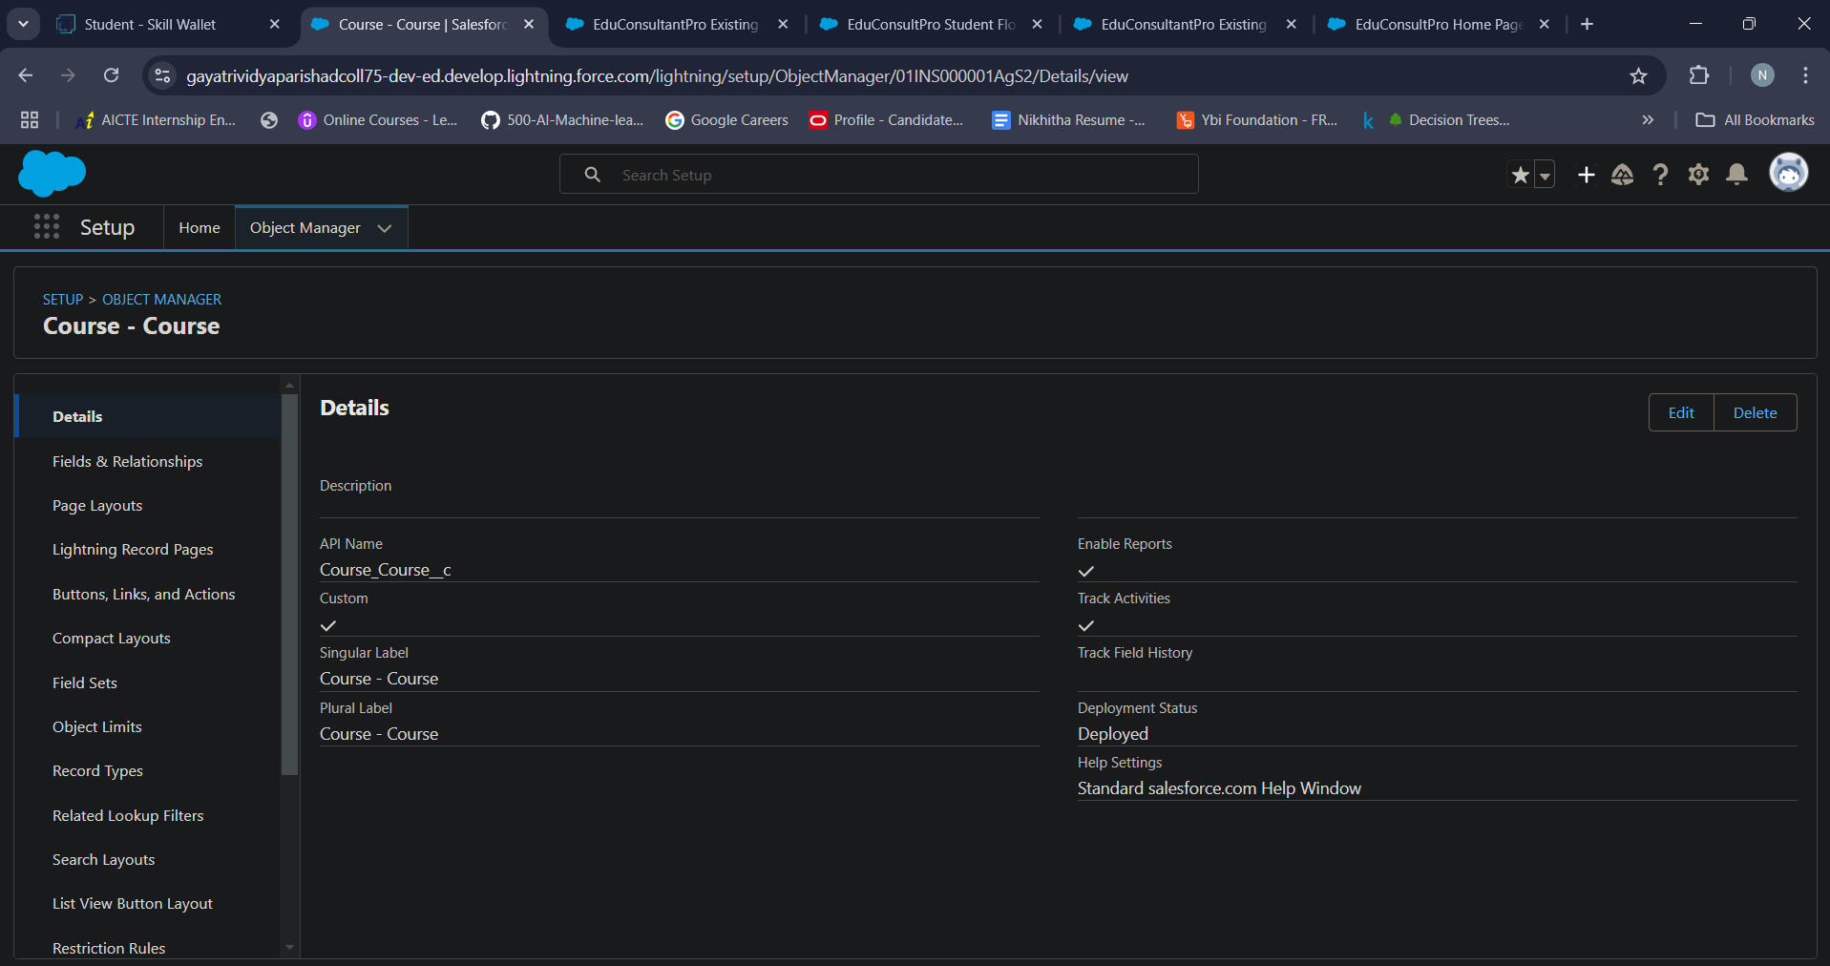

**Activity 2 - Create Relationship among the objects**

To create relationship among the objects follow these steps:

* Click on object manager
* In quick find search for the required object
* Next select field and relationships from left side of the panel
* Click on New
* Select lookup relationship, then next
* Select the related object (other object to which this object is related) and next
* Enter the label and name of the lookup and next
* Establish field level security for reference field and next
* Add reference field to Page Layouts and next
* Add custom related lists and save

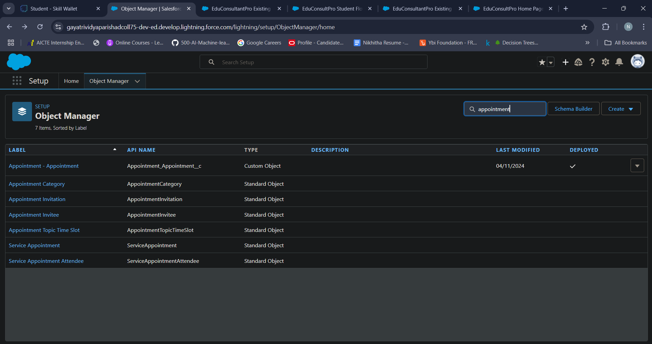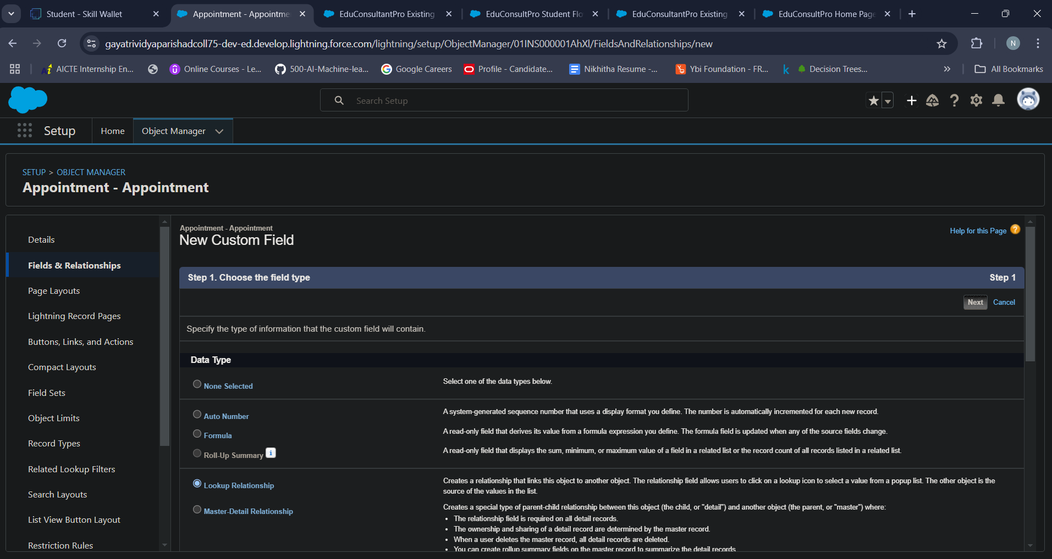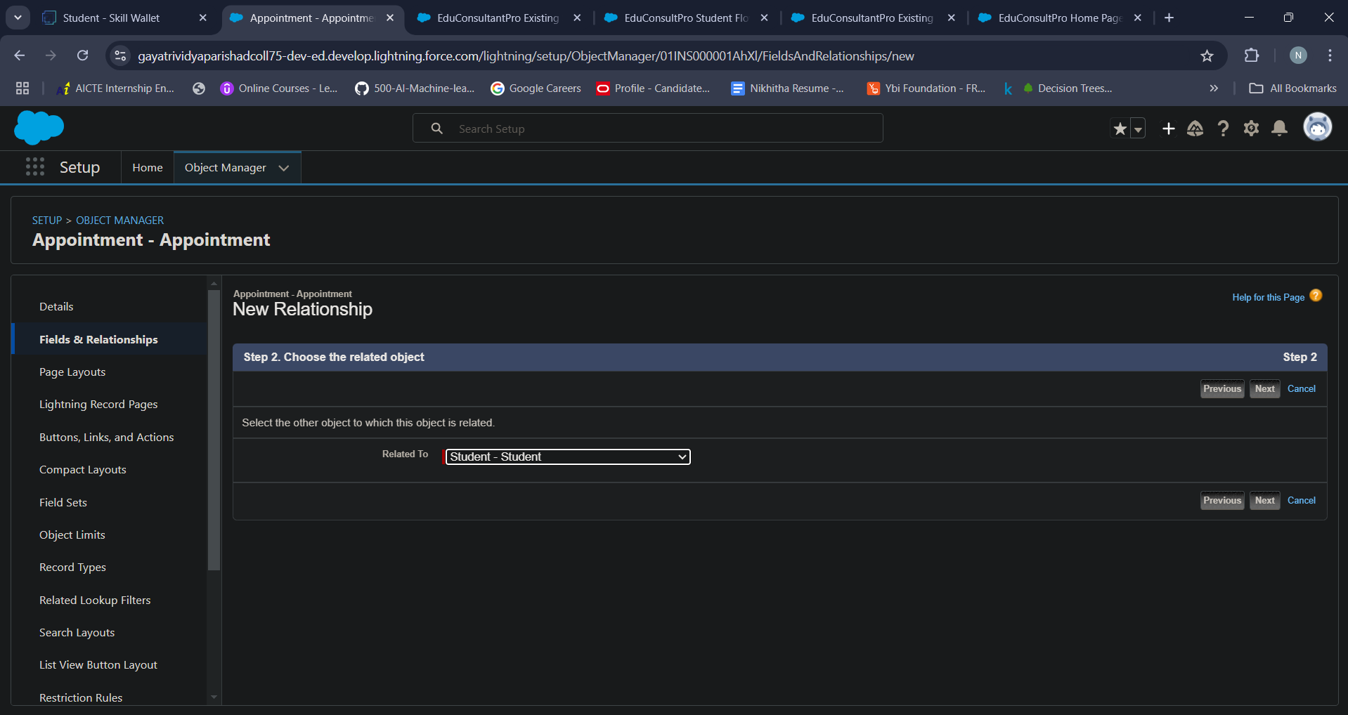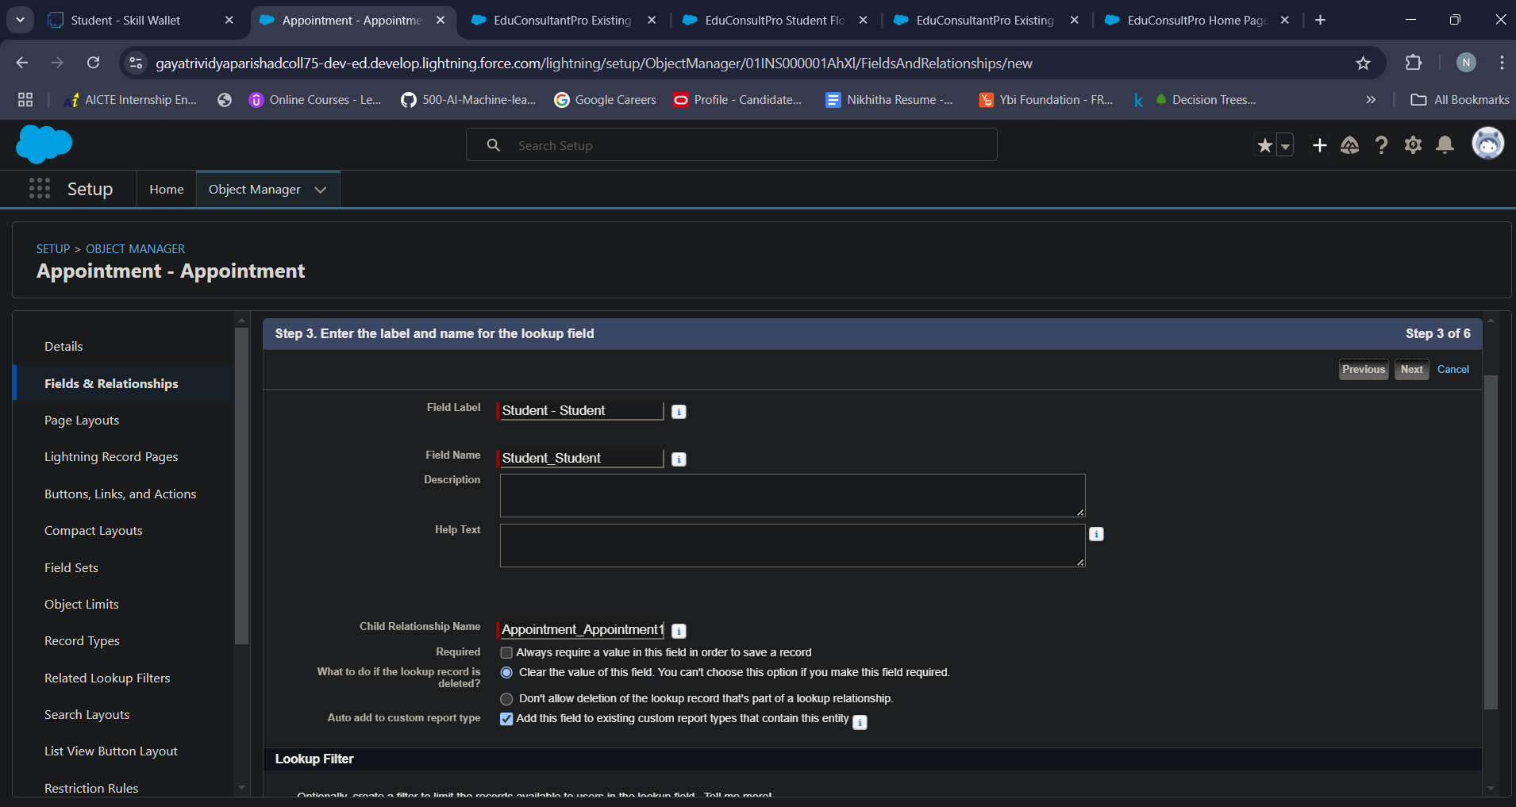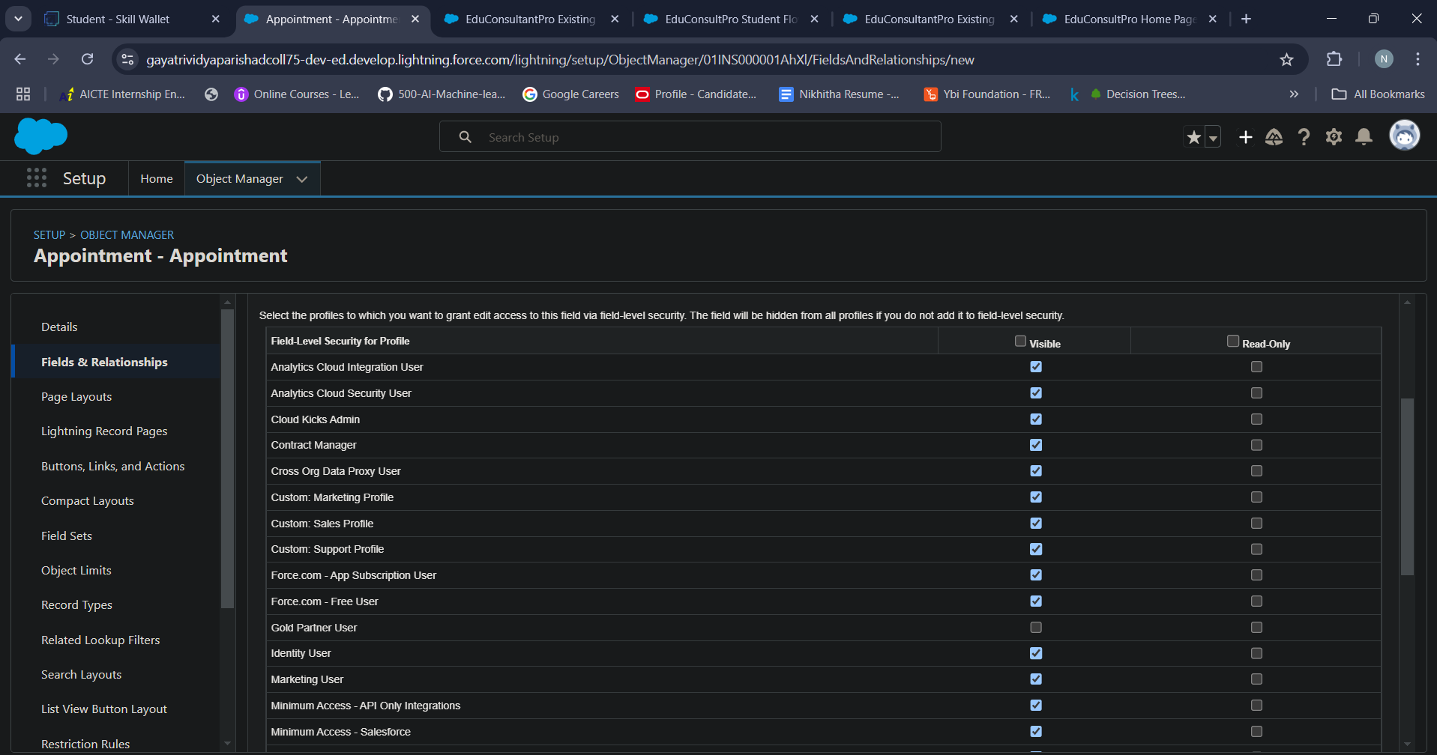

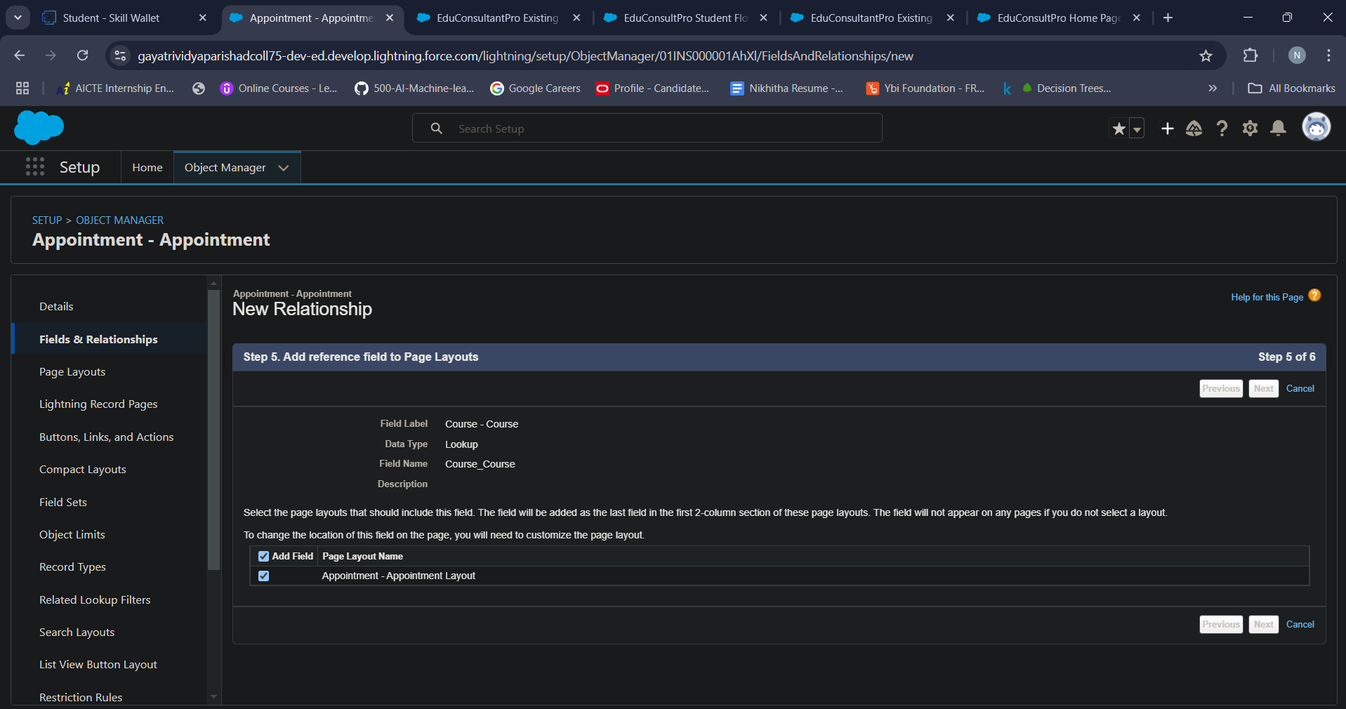

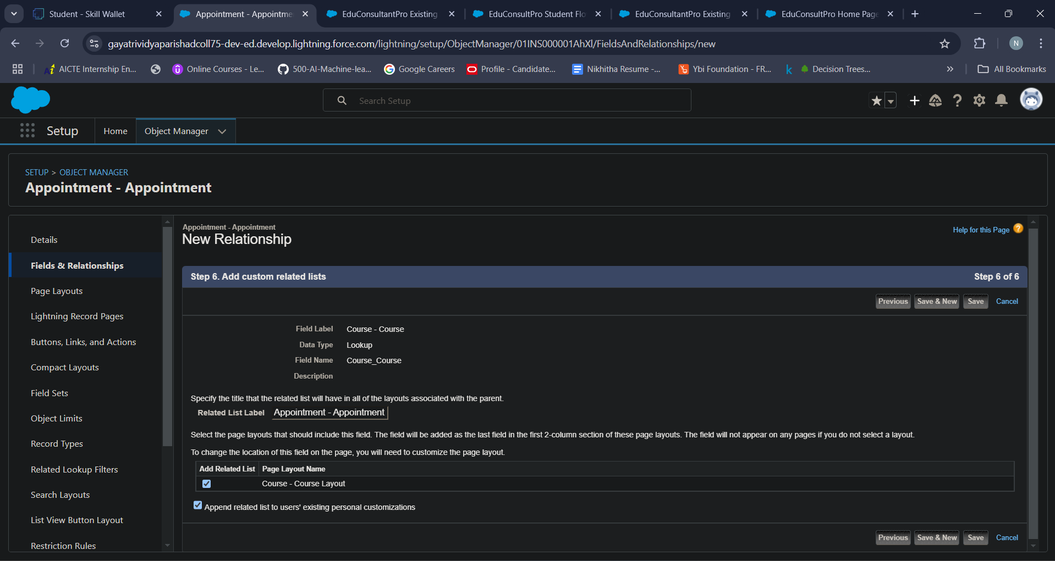

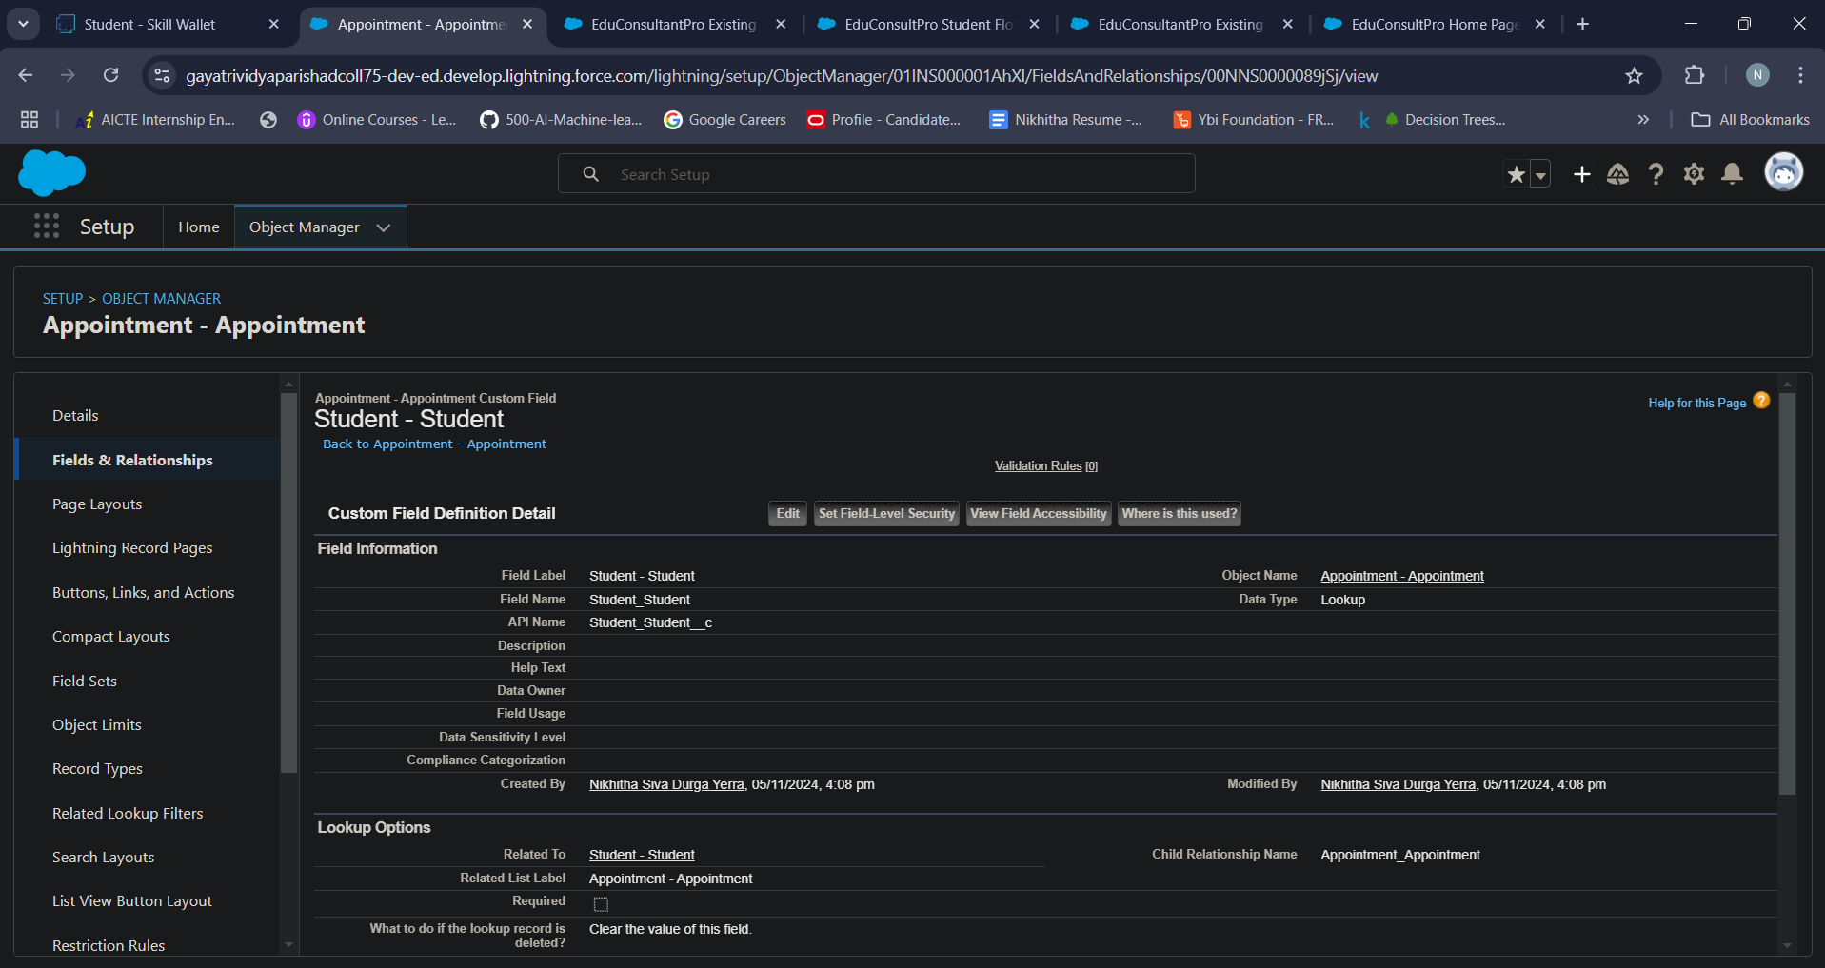

**Activity 3 - Configure the Case Object**

To configure the Case Object in Salesforce, follow these steps

* Go to object manager quick find case object
* Go to field and relationships and find Type and Status fields
* Go to case type picklist values and click on new
* Add the name of the case Immigration and save
* Do the same for Visa Application
* Next go to status field in case
* Go to fields and relationships, click new in case type picklist values
* Enter the status name and save
* Follow the same for in-progress

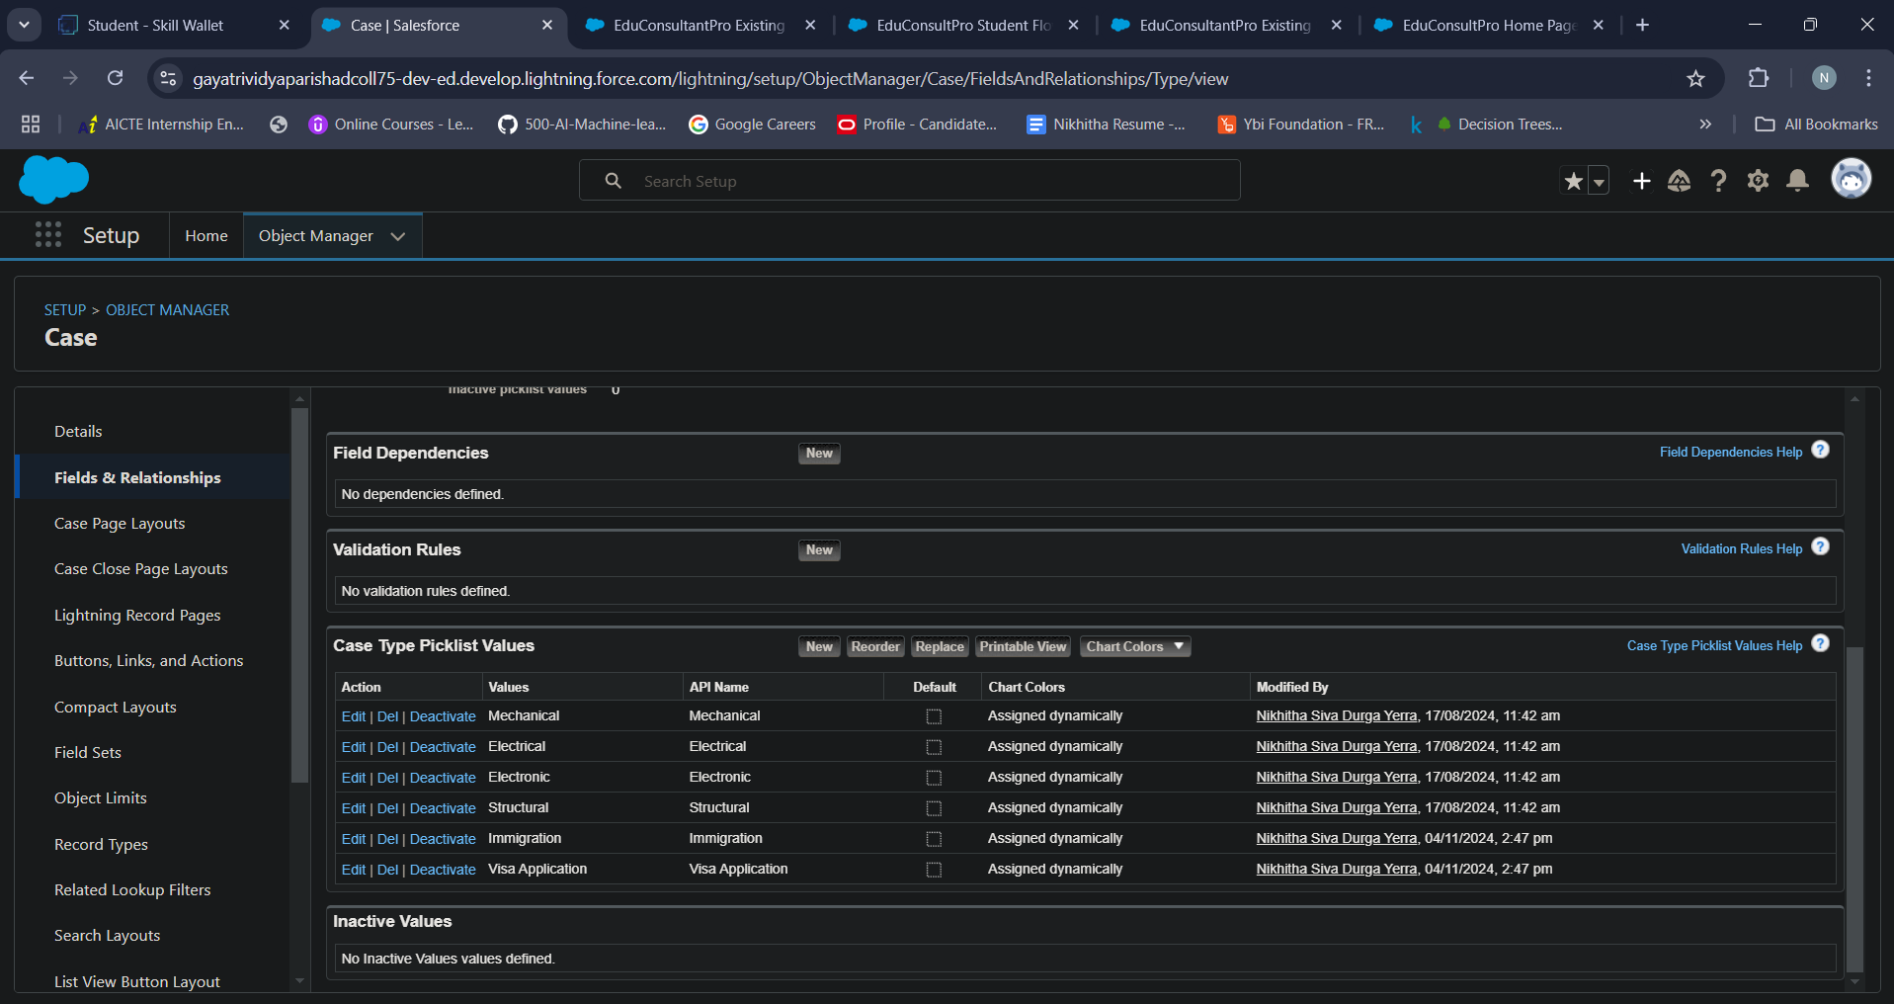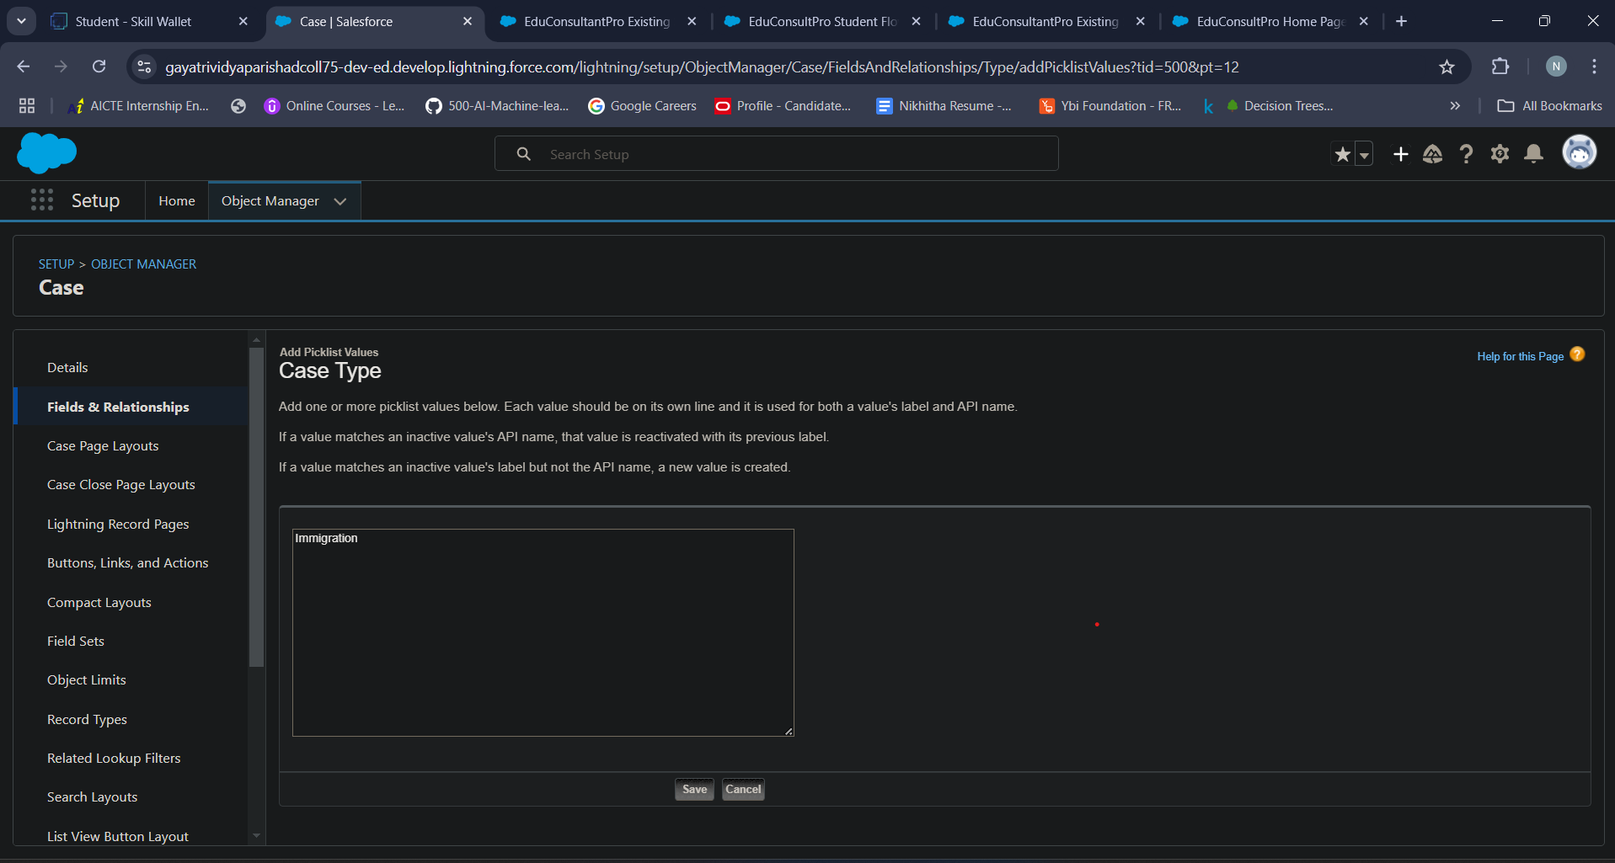

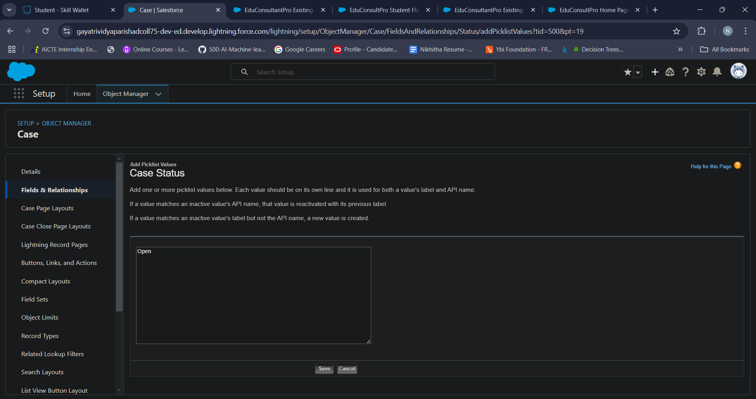

**Activity 4 - Create a Lightning App**

To create a Lighting app in Salesforce, follow these steps

* Go to Setup, search for the App Manager in quick find
* Click on New Lightning App
* Give app name as “EduConsultPro”, click Next, Next, Next
* Add Home, Students, Courses, Consultants, Appointments, Registrations, and Cases from the Available Items to Selected Items.
* Add “System Administrator” profile from Available Profiles to Selected Profiles, click Save & Finish.
* 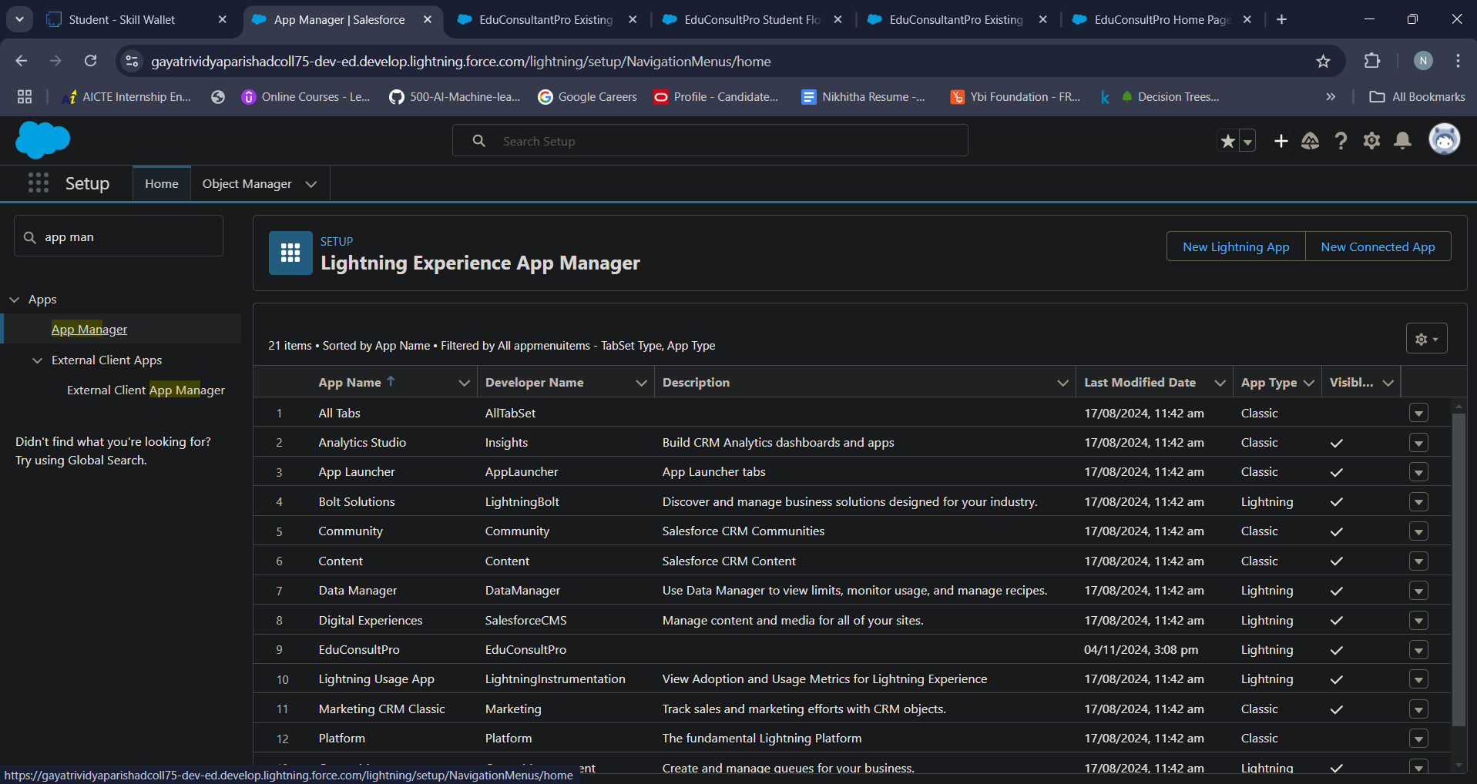
* 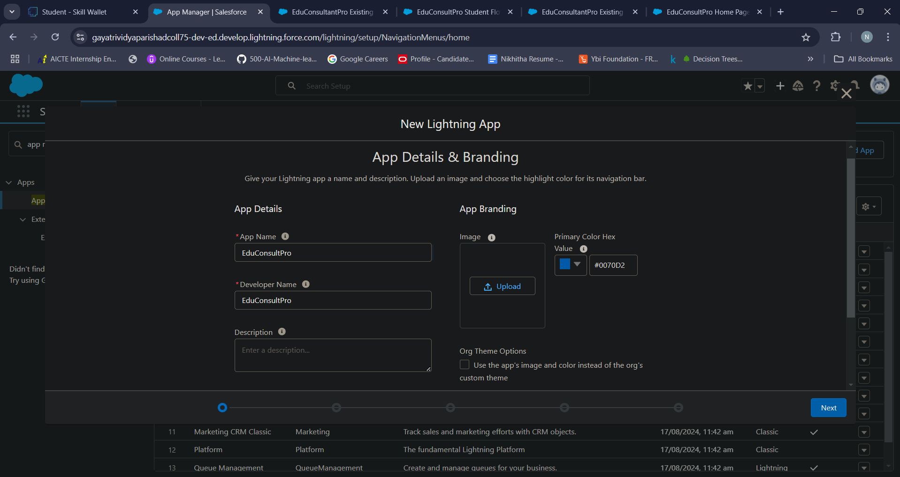

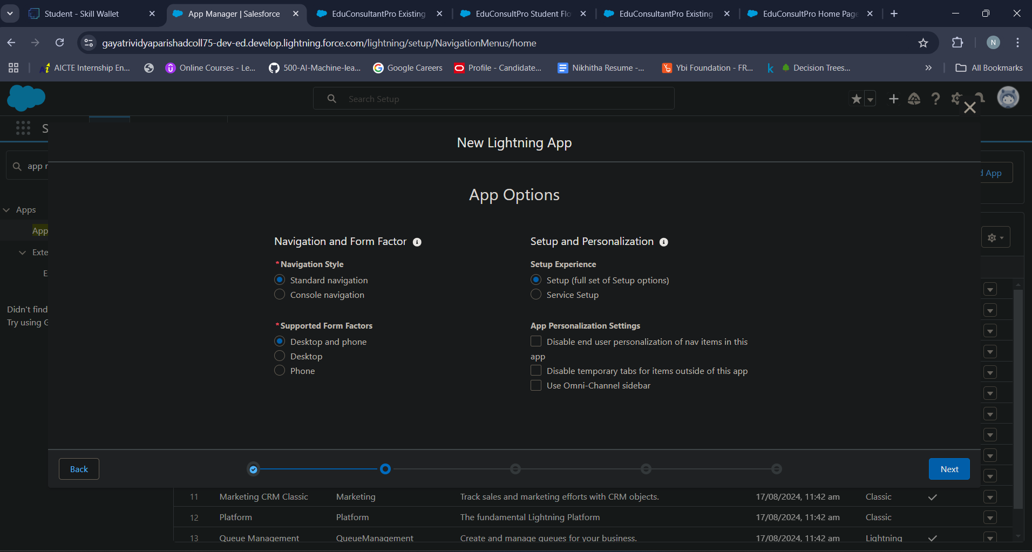

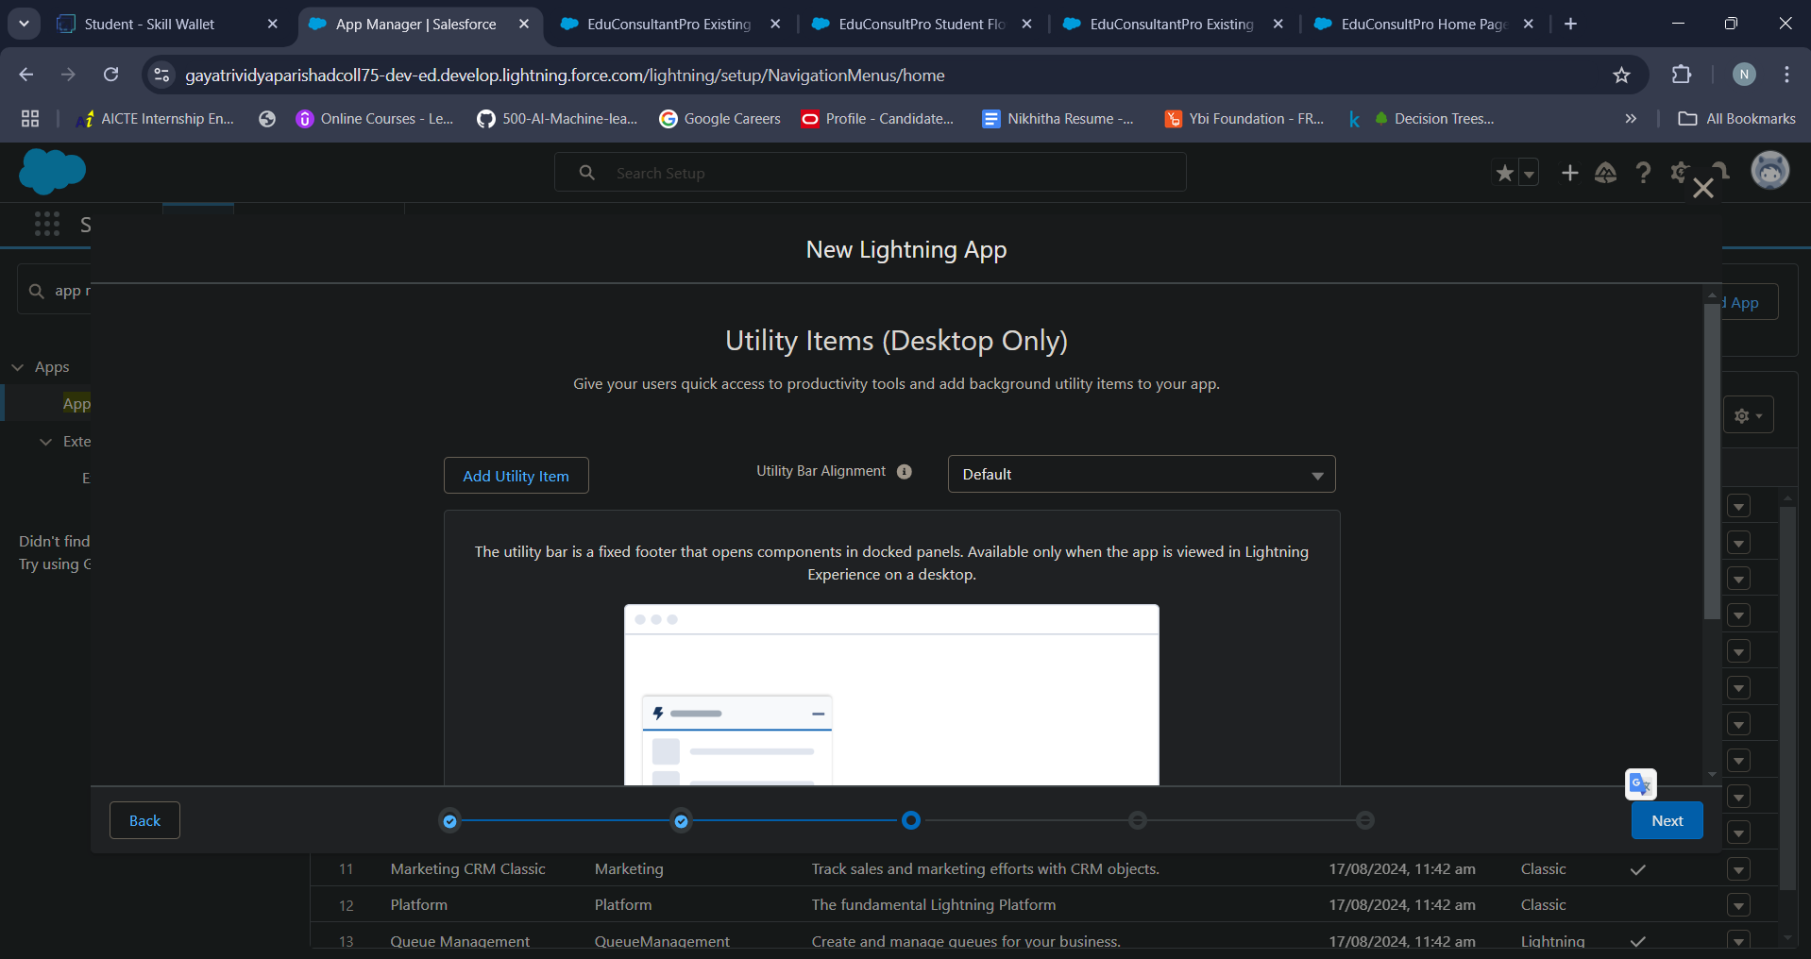

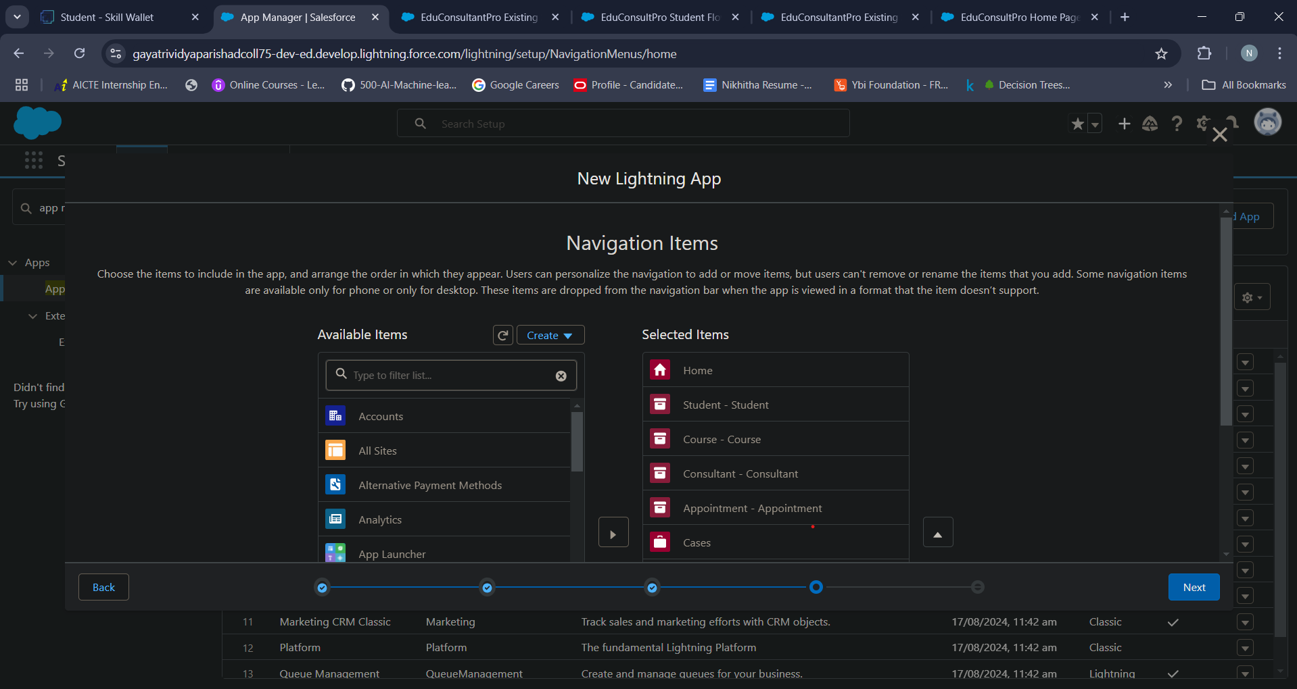

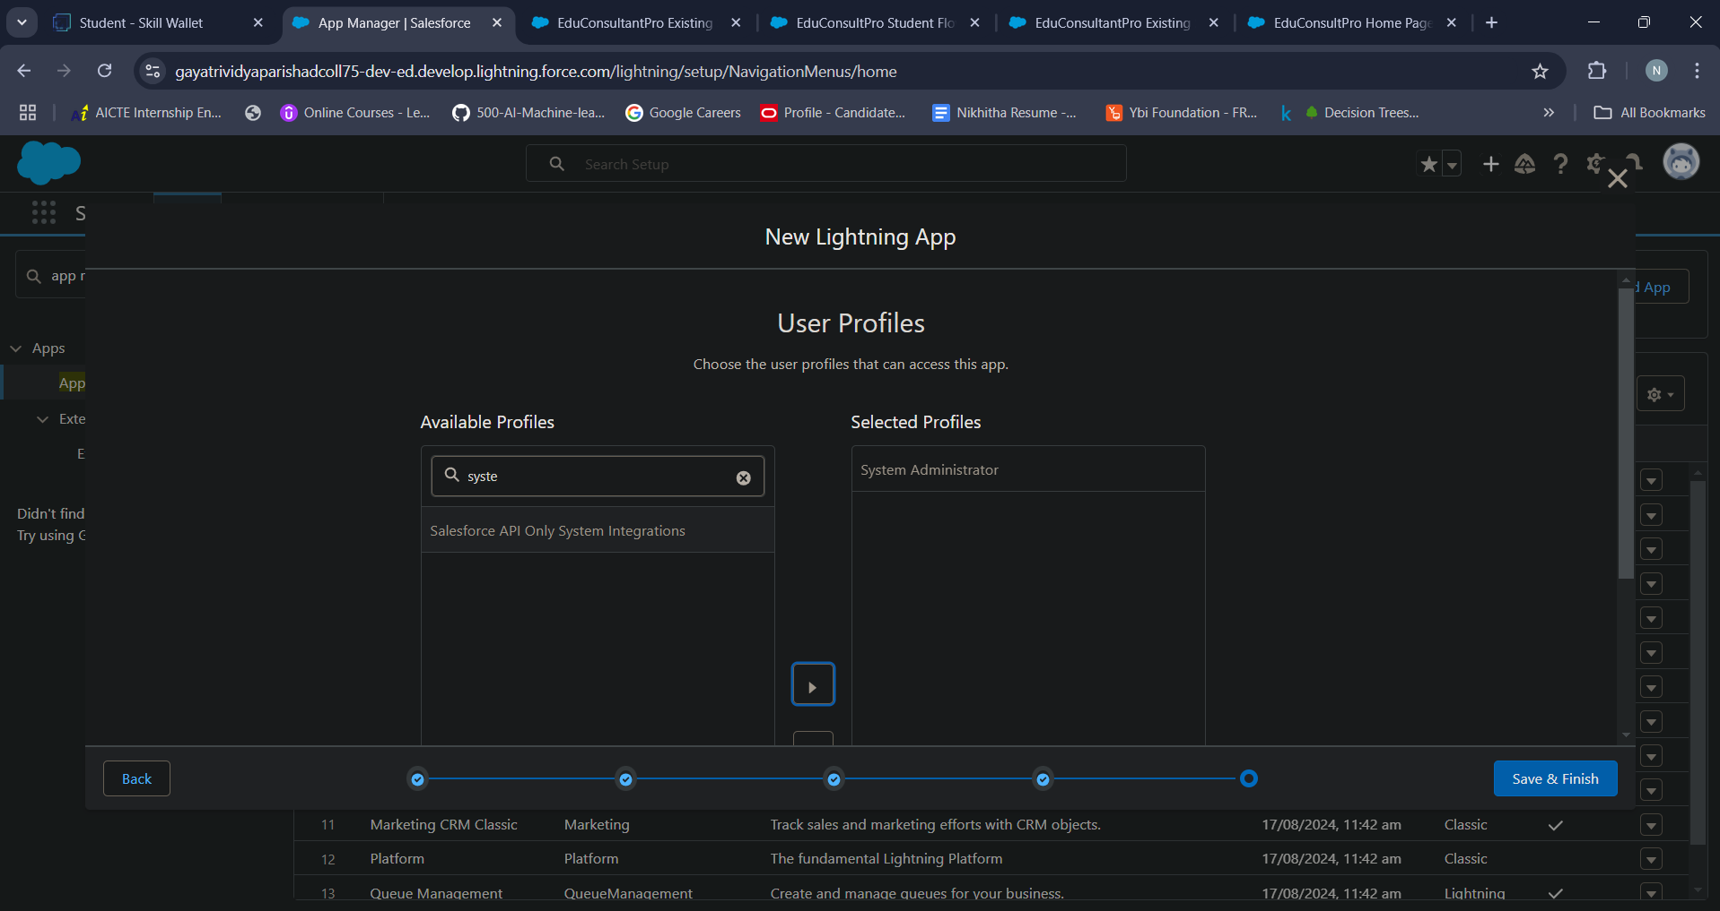

**MileStone 3 - Create a ScreenFlow for Student Admission Application process.**

Screen Flow in Salesforce, part of the broader Flow Builder, is a tool for creating guided, interactive workflows and automated processes within the Salesforce platform. It allows administrators and developers to design and implement multi-step processes that guide users through screens, which can involve collecting and displaying data, and interacting with Salesforce records.

**Key Features of Screen Flow:**

* User Interaction: Screen Flows are designed to engage users by presenting a series of screens where they can input information, make selections, and navigate through custom workflows.
* Automated Processes: Screen Flows can automate tasks like creating or updating records, querying databases, sending emails, and much more. This reduces the need for manual data entry and task repetition.
* Logic and Decision Points: Screen Flows support conditional logic, allowing for decisions to be made based on user inputs or existing data, which can guide the user down different paths within the flow.
* Integration with Salesforce Records: Screen Flows can be set up to retrieve, display, and update Salesforce records, making them highly useful for managing customer interactions, data entry, or any workflow involving CRM data.
* Embed and Trigger: Screen Flows can be embedded on Salesforce pages, such as on the home page or record pages, and can be triggered from buttons, links, or other flows. This flexibility makes them versatile for various use cases across Salesforce.

**Activity 1- Add Screen Element**

To create a screen element, follow these steps

* From Setup, enter Flow Builder in quick find, select new flow --> ScreenFlow.
* Add a Screen element.
* In the Screen Properties pane, for Label, enter “Student Info”.
* Click on Fields, click on the record variable input and create a new Resource(StudentRecordRes) to display all the fields which are in the student object. Drag all the fields which are needed to add on the screen inorder to collect the student information.

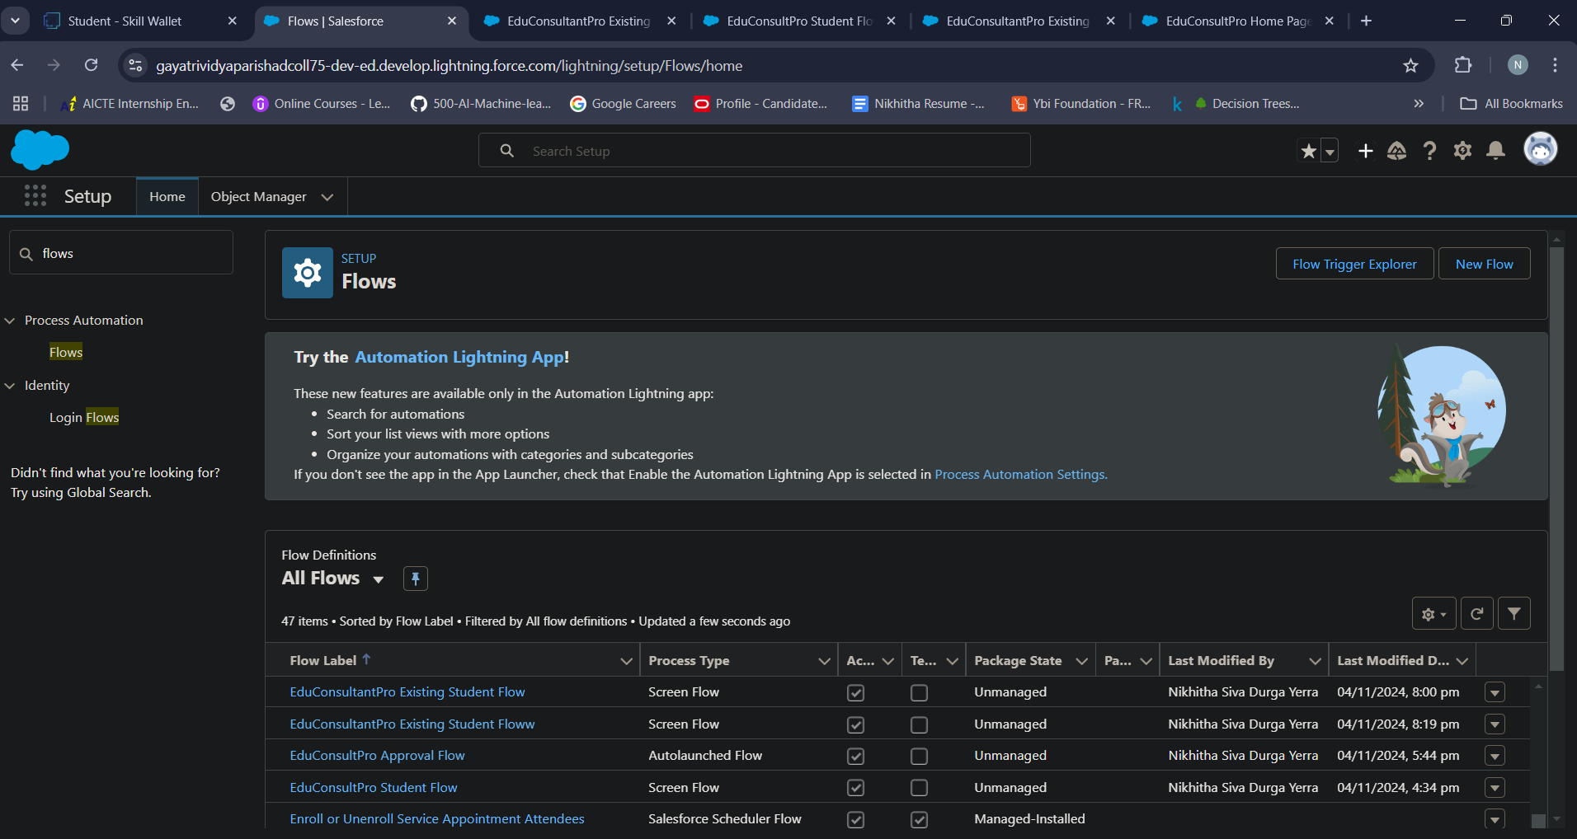 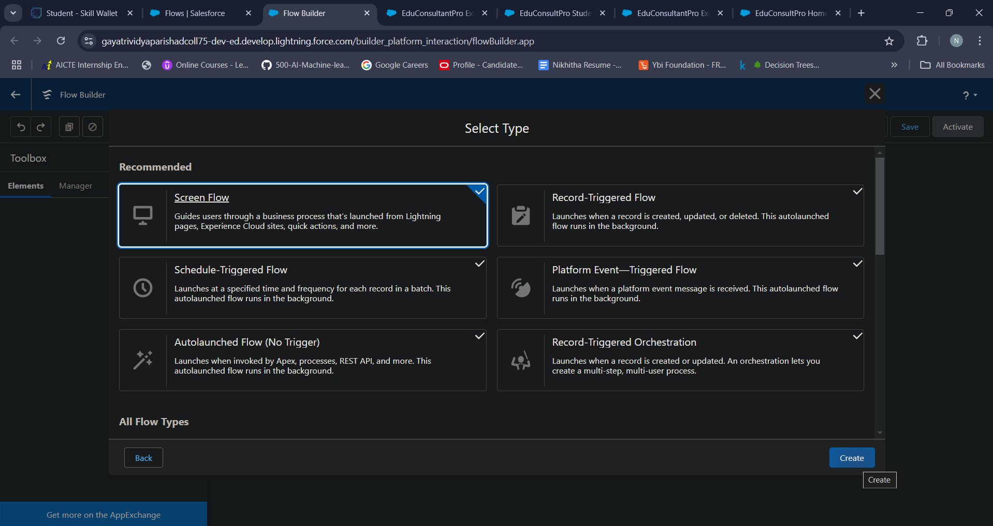

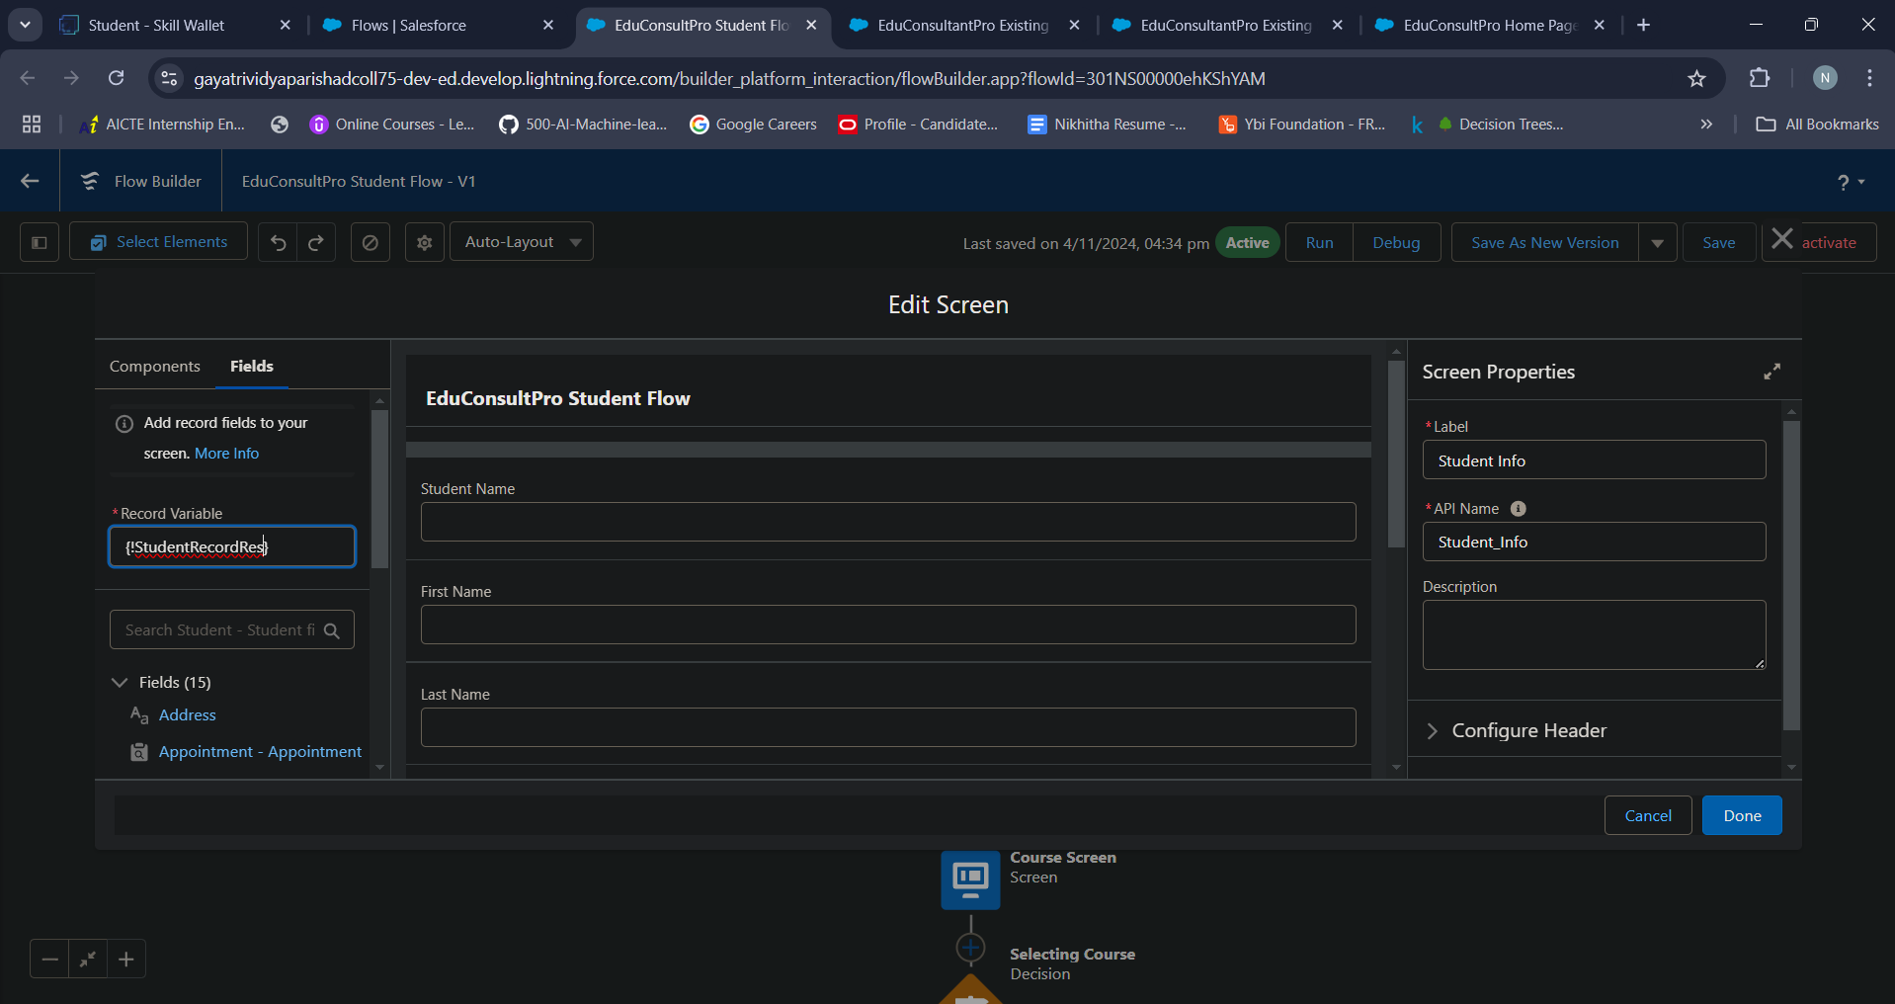

**Activity 2 - Create Student Record using Create Element**

* Add a Create element after Student Info Screen Element, Label it as “Create Student Record.”
* Select “one” under How many records to Create, and select “use all values from a record” under How to Set the record fields.
* Select the record variable resource(StudentRecordRes) which we have created in the Student Info screen element, under Create a record from these values.

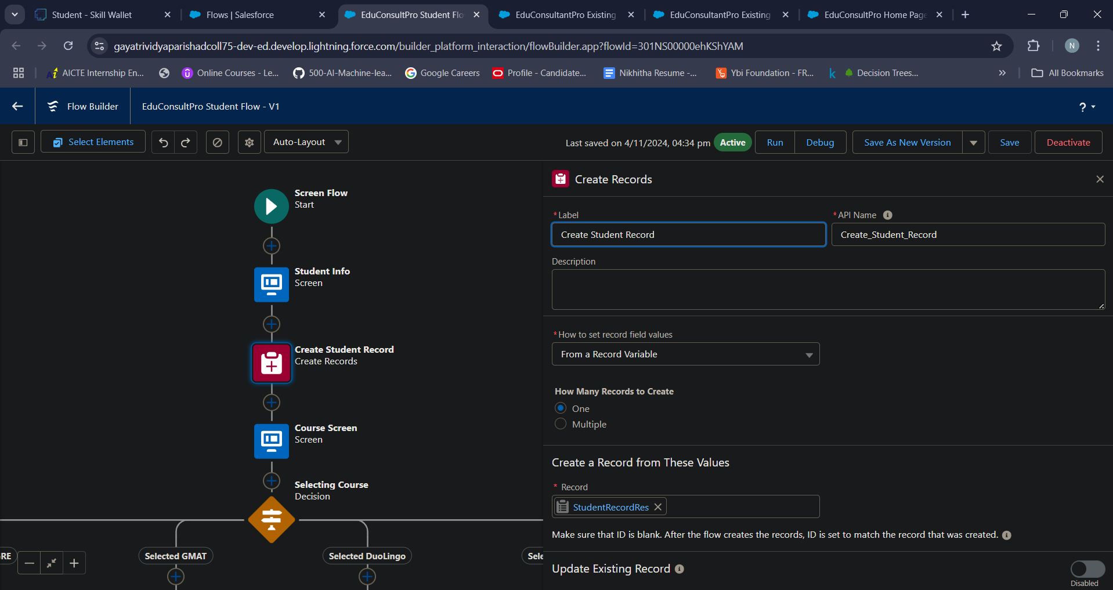

**Activity 3 - Add Screen Element**

* Add a Screen Element after Create Student Record Element and label it as Course Screen.
* Add a picklist component from the left side panel label it as “Select Course”, under choices type “IELTS” and enter. This creates a variable with the name IELTS.
* Repeat the same for GRE, GMAT, Duolingo, TOEFL.

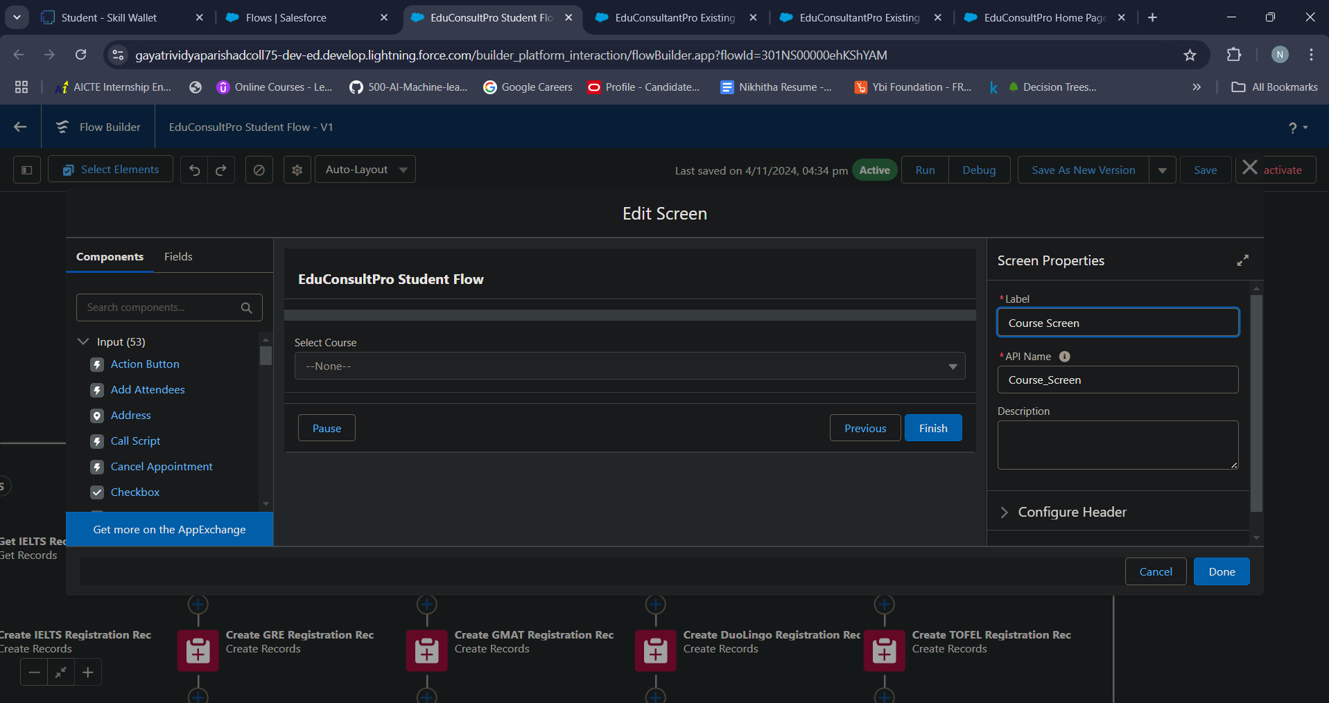

**Activity 4 - Add Decision Element**

* Add a Decision Element after Select Course Screen Element, label it as Selecting Course.
* Under outcome label it as “Selected IELTS” and write the condition such as below:
* Resource : Select_Course (Screen Component from Select Course Screen Element)
* Operator : Equals
* Value : IELTS (Choice Variable from Select Course Screen Element)
* Click on the “+” icon and Repeat step 2 for other options mentioned as below:
* GRE
* GMAT
* DuoLingo
* TOEFL
* Click Done

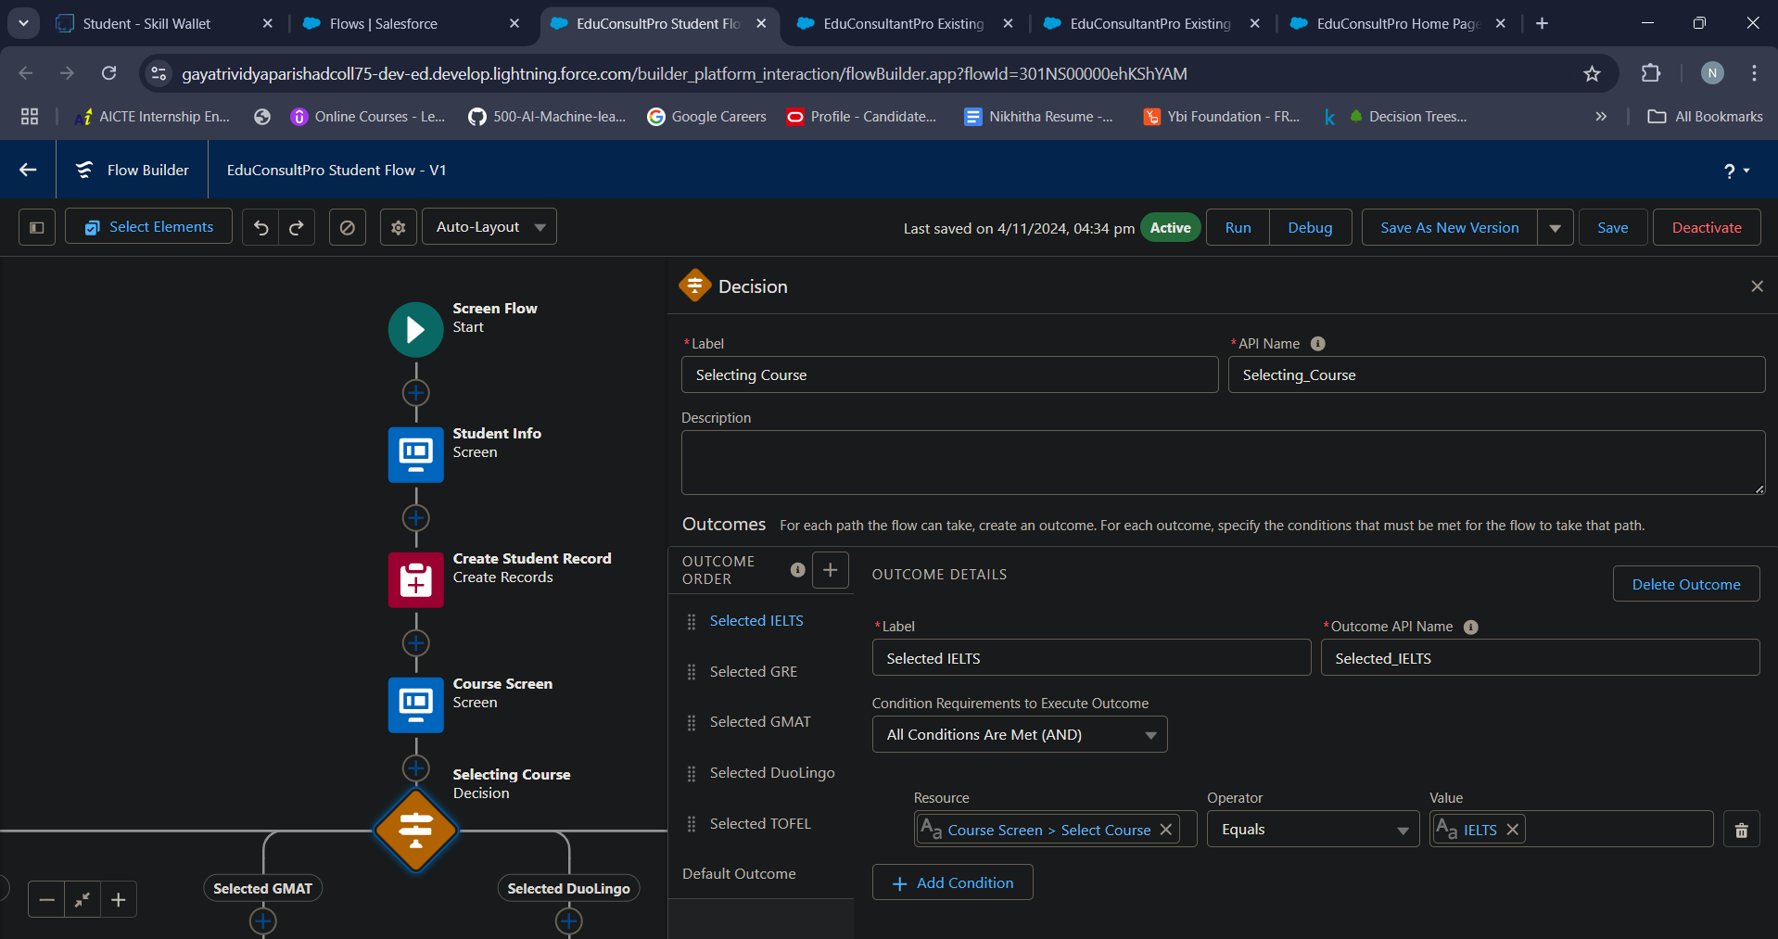

**Activity 5 – Add GET Record Element**

* Add a GET Record Element after Decision Element, under the IELTS path and label it as “Get IELTS Rec”.
* Select Object : Course

Condition Requirement : All Conditions are Met(AND)

Field : Course Name

Operator : Equals

Value : {!Select_Course}

* Repeat the steps 1 & 2 for the GRE, GMAT, TOEFL, DuoLingo paths.

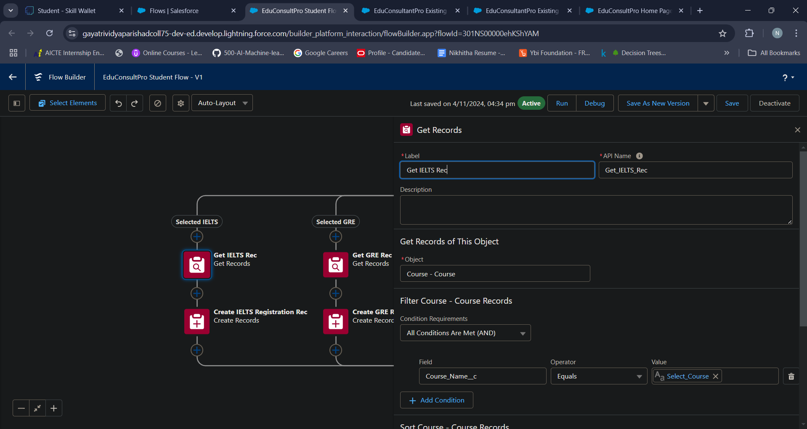

**Activity 6 – Create Registration Record using Create Records Element**

* Add a Create element after the Get IELTS Rec element and label it as “Create IELTS Registration Rec”.
* Select “one” under How many records to Create, and select “Use separate resources, and literal values” under How to Set the record fields.
* Select Object : Registration

Field : Course_Name__c

Value : {!Get_IELTS_Rec.Id}

Field : Student_Name__c

Value : {!StudentRecordRes.Id}

* Repeat the steps 1 & 2 for the GRE, GMAT, TOEFL, DuoLingo paths.

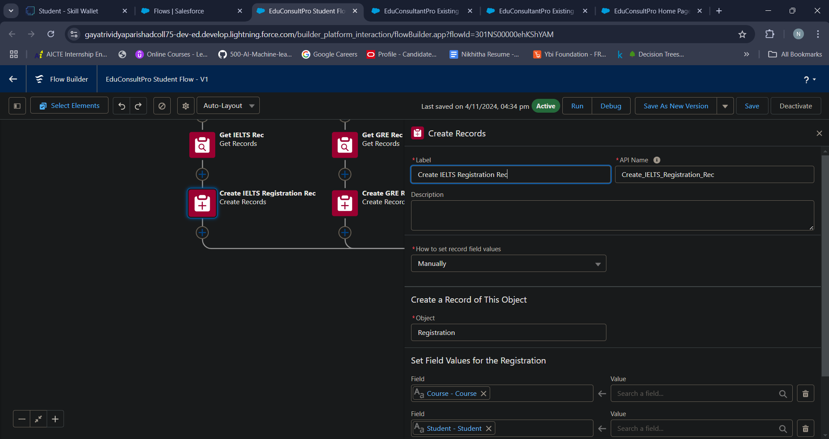

**Activity 7 – Create Email Text Template Variables for email body and subject**

* Click on the toggle toolbox on the left corner, click “New Resource”, then select “Text Template” as Resource Type.
* Give the API name as “StuRegistrationEmailTextTempBody”, select “view as plain text” and paste the below text in body.

“Dear {!StudentRecordRes.Name},

Congratulations and welcome to EduConsultantPro!

We are delighted to inform you that your registration on our platform has been successfully completed. You are now part of our esteemed community dedicated to empowering students like you to achieve their educational and immigration aspirations.

At EduConsultantPro, we understand the importance of your academic and career goals, and we are committed to providing you with the highest level of support and guidance throughout your journey.

Here are a few key points to help you get started:

Explore Our Resources : Take some time to explore the wide range of resources, tools, and services available on the EduConsultantPro platform. From educational insights to immigration advice, we offer comprehensive support tailored to your needs.

Connect with Our Consultants : Our team of experienced consultants is here to assist you at every stage of your educational and immigration endeavors. Don't hesitate to reach out to us with any questions, concerns, or inquiries you may have. We're here to help!

Stay Updated : Keep an eye on your inbox for important updates, announcements, and exclusive opportunities from EduConsultantPro. We'll ensure that you're informed about the latest developments and relevant information to support your journey.

Engage with the Community : Join our vibrant community of students, professionals, and experts who share your passion for education and global opportunities. Connect with like-minded individuals, participate in discussions, and expand your network.

Once again, congratulations on taking this important step towards realizing your academic and career aspirations. We are thrilled to have you as part of the EduConsultantPro family and look forward to supporting you on your journey to success.

If you have any questions or need assistance, please don't hesitate to contact us.

Thank you.”

* Click Done.
* Repeat steps 1 & 2 to create an email text template for the email subject, label it as “StuRegistrationEmailTextTempSub”, write a text message in the body and save it.

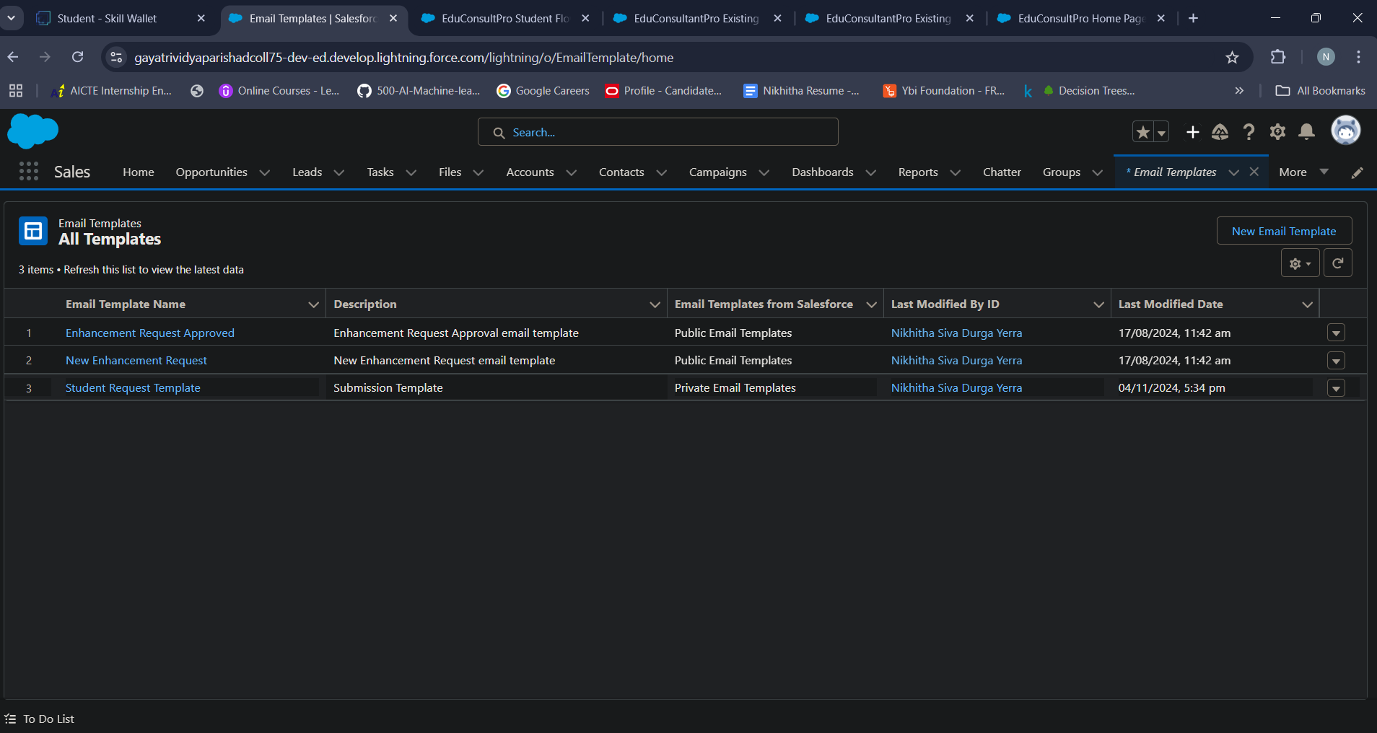

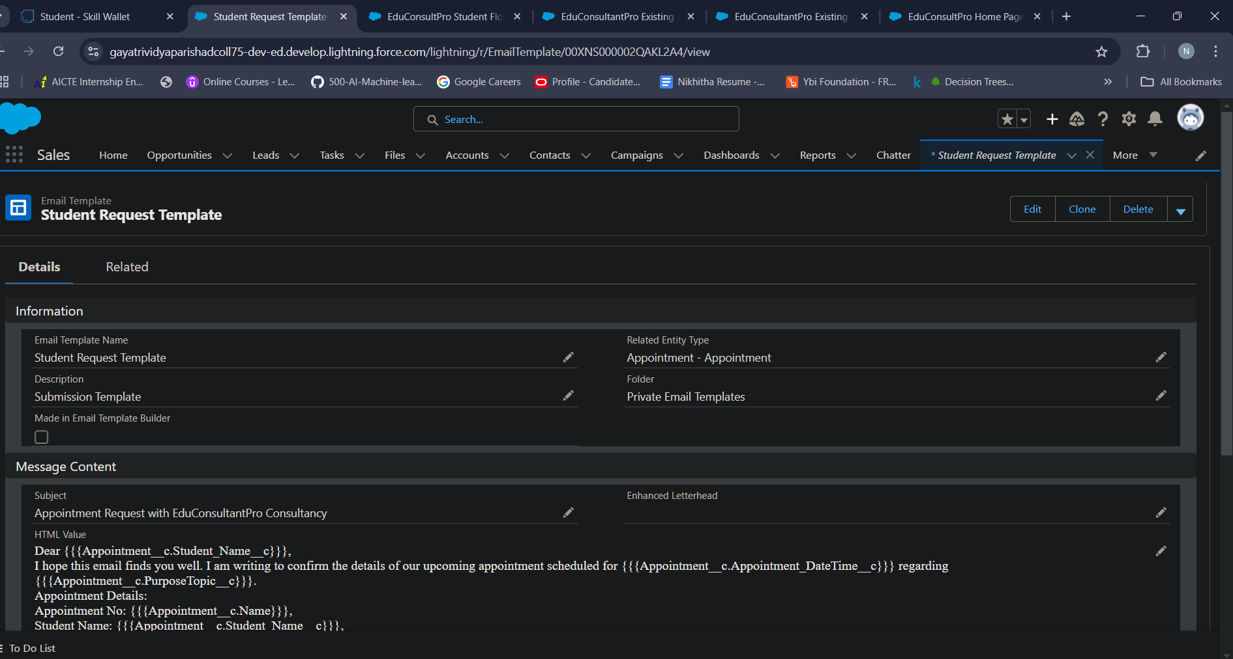

**Activity 8 – Add an Action Element**

* Add an Action Element after all the Decision paths, label it as “Send Email to Student”.
* Under “Set input values for selected action”, include body, Recipient Address List and Subject.
* For input Body : {!StuRegistrationEmailTextTempBody},

Recipient Address List : {!StudentRecordRes.Email__c},

Subject : {!StuRegistrationEmailTextTempSub}.

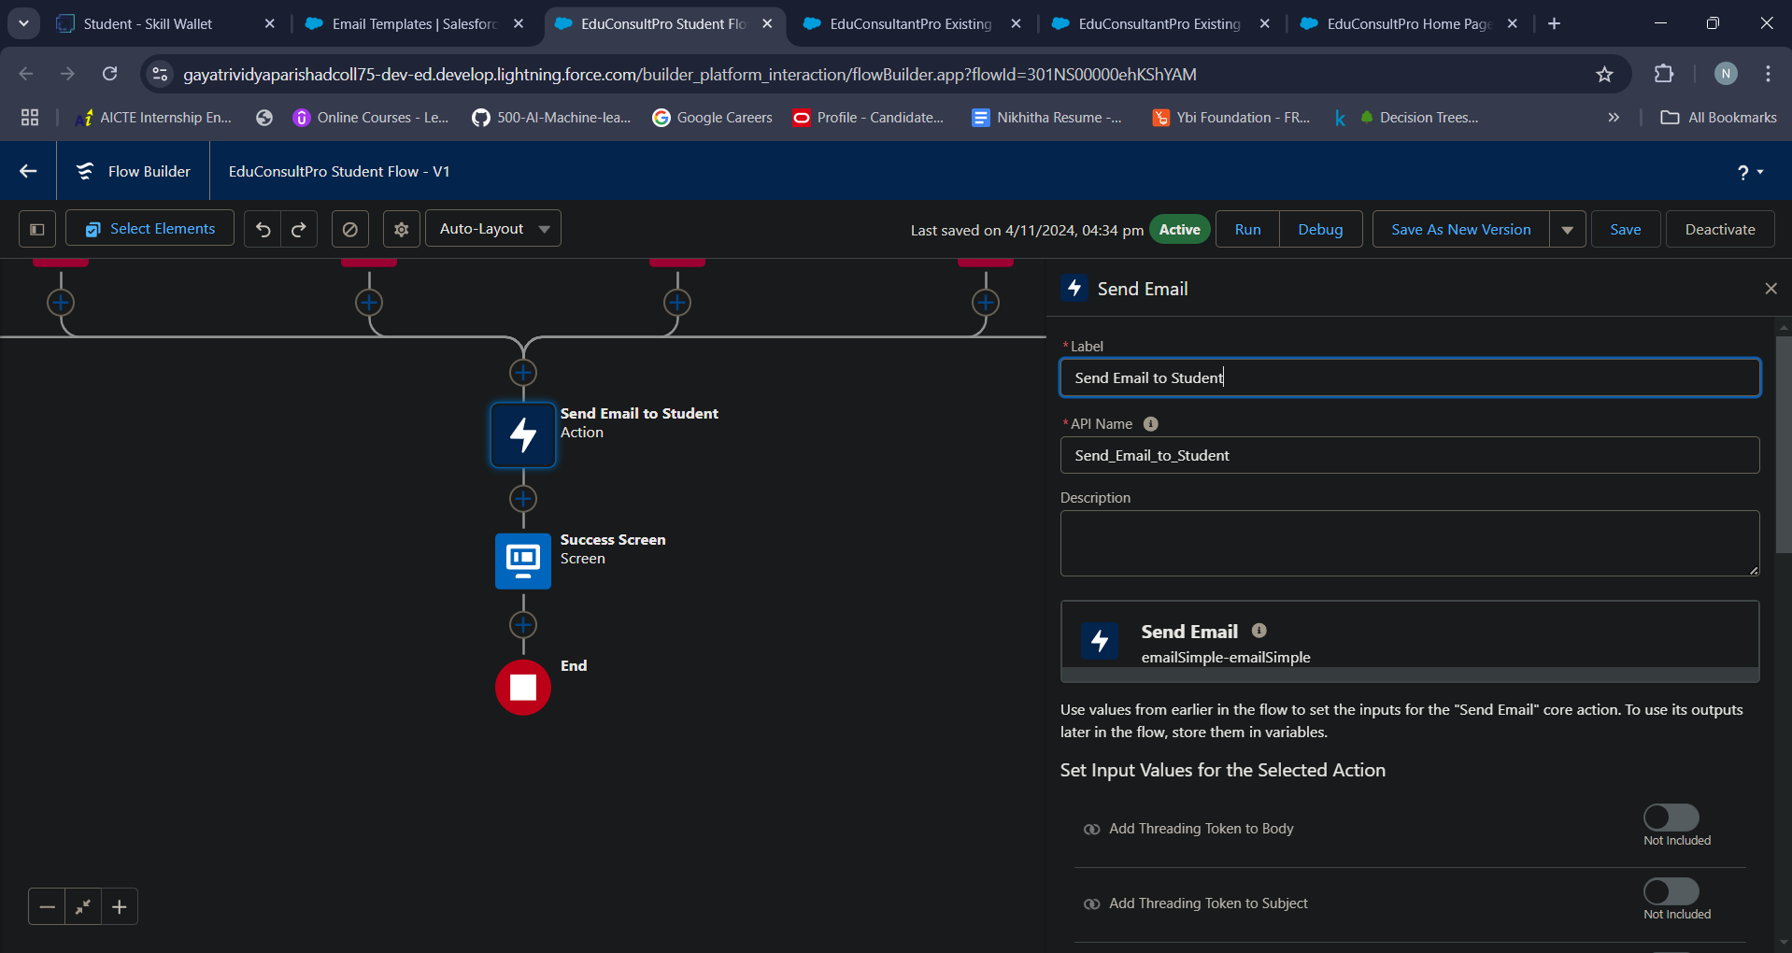

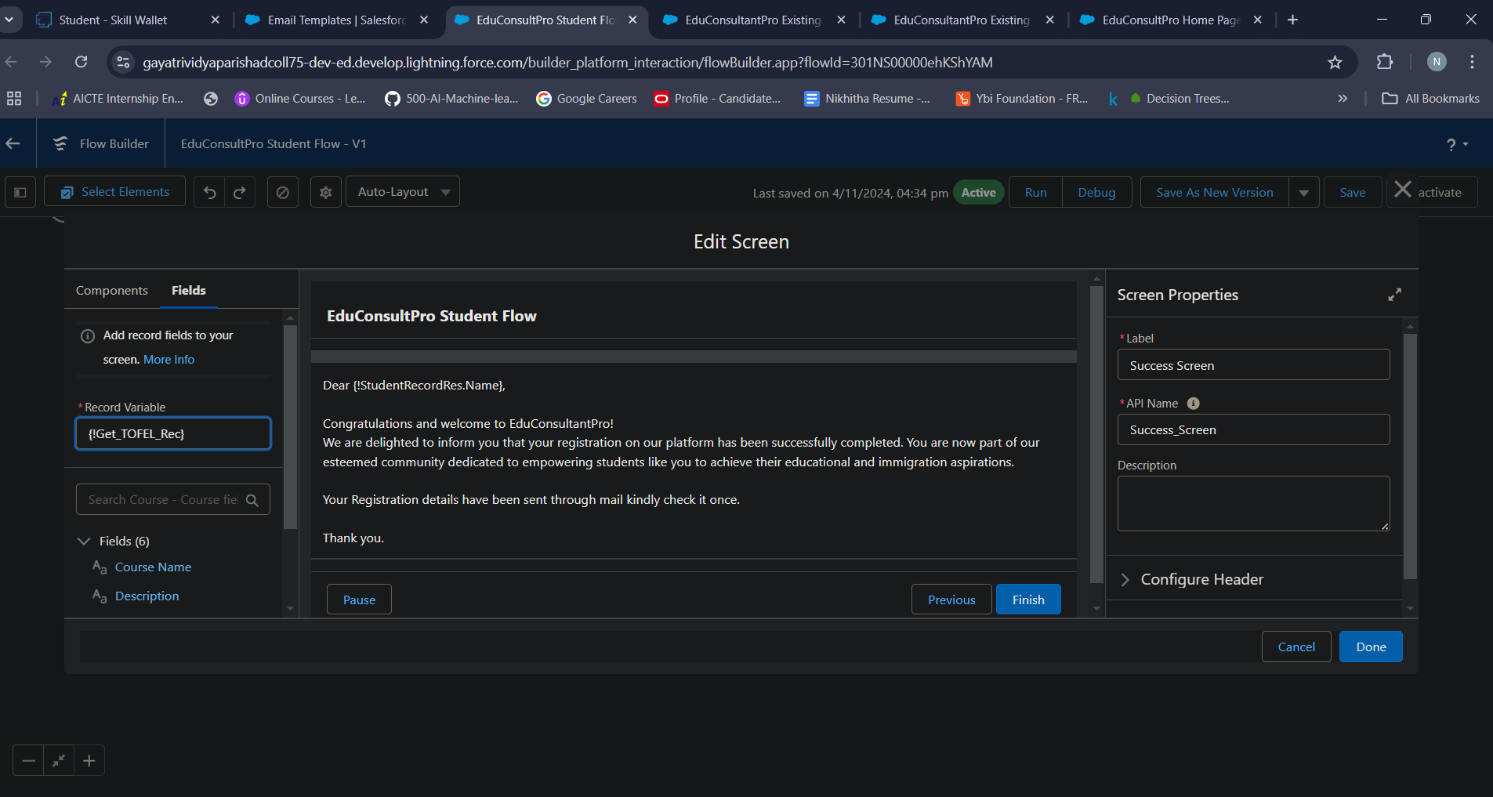

**Activity 9 – Add a Screen Element after the Send Email to Student Action Element, label it as Success Screen.**

* From the left side panel search for the Display text component and drag it to the main panel, label it as “SuccessMessage”.
* Paste the below in the Resource picker box.

“Dear {!StudentRecordRes.Name},

Congratulations and welcome to EduConsultantPro!

We are delighted to inform you that your registration on our platform has been successfully completed. You are now part of our esteemed community dedicated to empowering students like you to achieve their educational and immigration aspirations.

Your Registration details have been sent through mail kindly check it once.

Thank you.”

Click Done.

* Save the flow and name it as “EduConsultPro Student Flow”. Your flow will look as shown below:

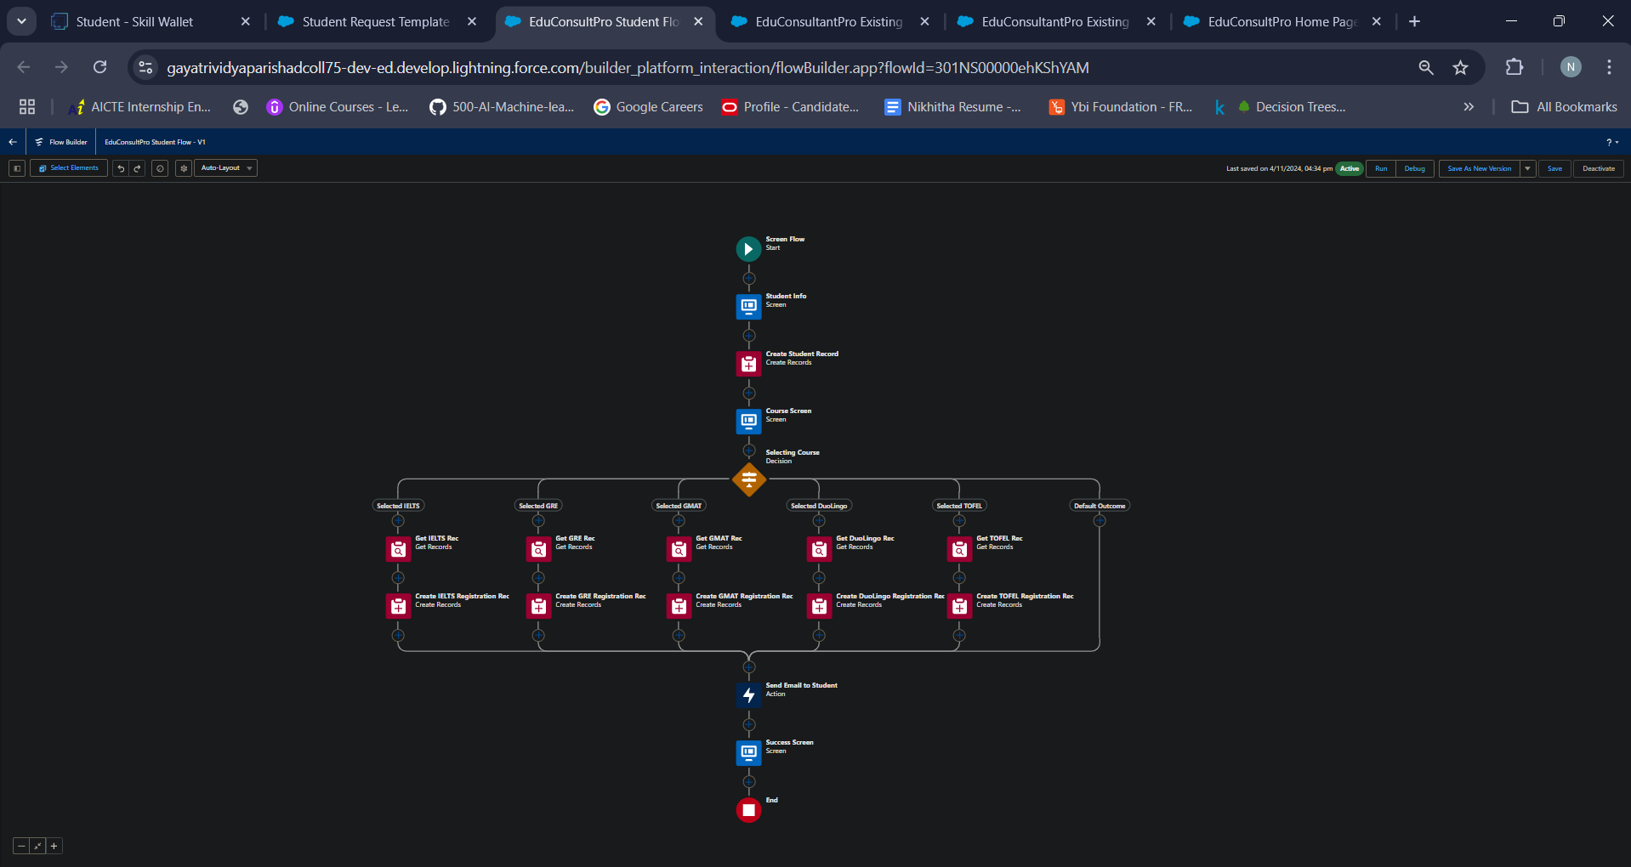

**MileStone 4 - Create Users**

Creating users in Salesforce is essential for enabling individual team members to access and interact with the platform according to their roles and responsibilities. Each user account in Salesforce allows specific access to data, permissions, and tools, ensuring security and efficient management of information.

**Activity 1 - Create a user with a Standard platform user profile.**

To create a user, follow these steps

* Go to Setup --> Administration --> Users --> New User
* LastName : Consultant

License : Salesforce Platform

Profile : Standard Platform User

* Fill all the mandatory fields & Save.

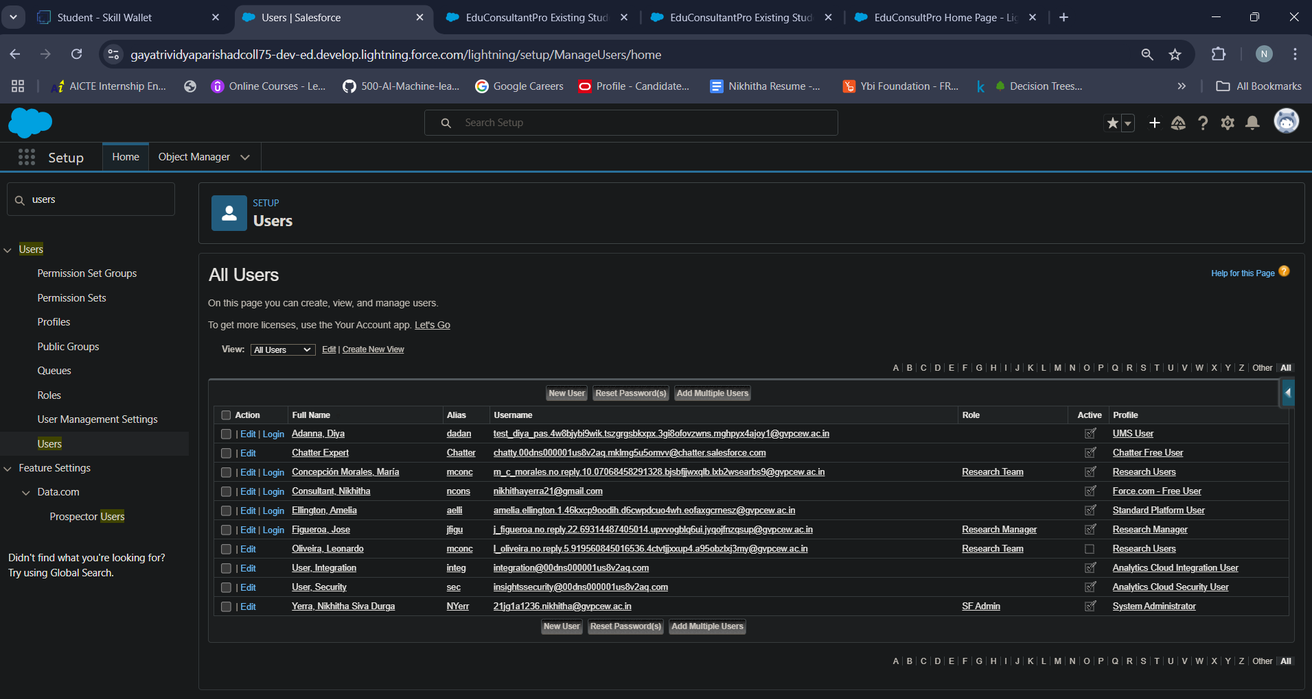

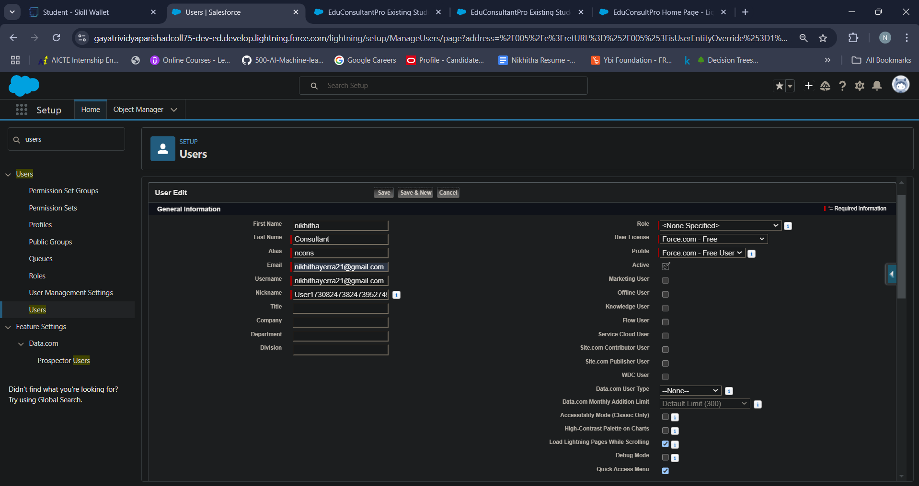

**Activity 2 - Configure the User Settings**

* Go to Setup --> Administration --> Users --> click Edit next to your name
* Scroll down to bottom, under Approver Settings, Select “Consultant” the Manager Field.
* Click Save.

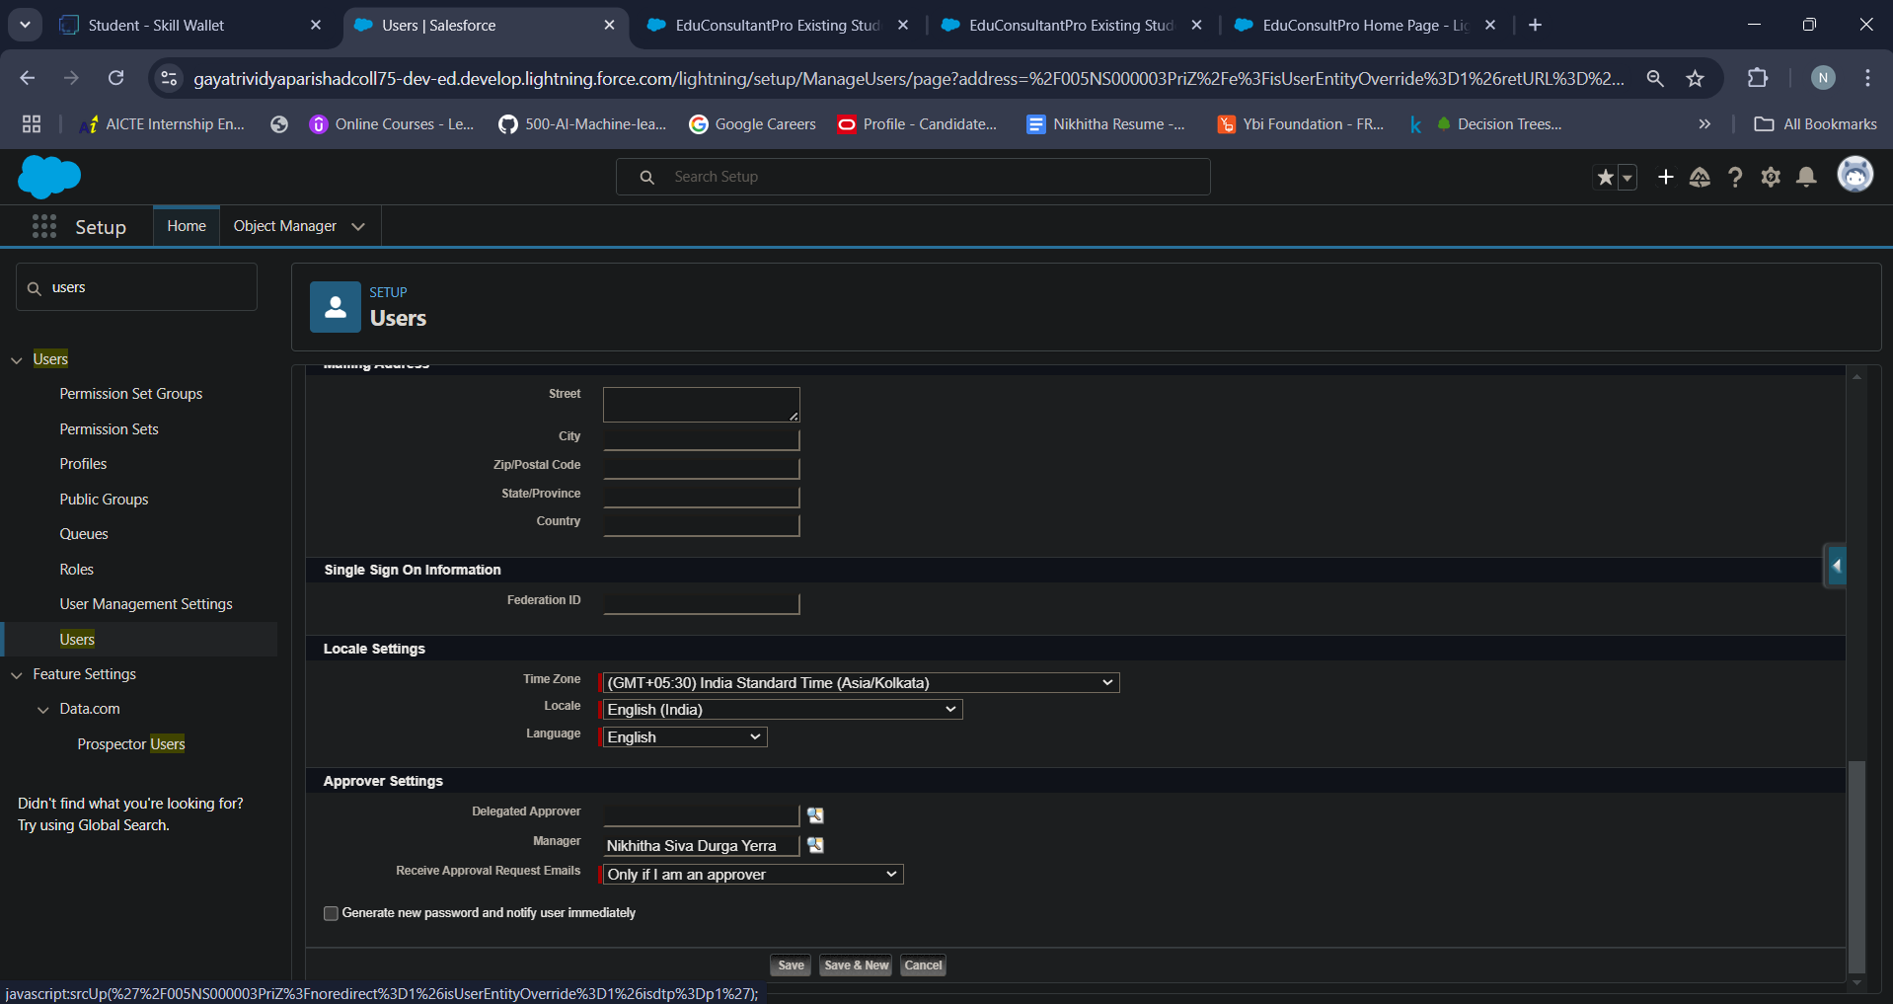

**MileStone 5 - Create an Approval Process for Property Object**

**Activity 1 - Create an Email Template**

* From Setup, enter Templates in the Quick Find box, and then select Lightning Email Templates, toggle on.
* Go to app launcher, search for “Email Templates”, Create a new folder with the desired name.
* Then create a new email template, select the folder which we have created in the previous steps, enter the below text in the HTML Value and Save it as "Submission Template".
* Create two more Email templates for Approval and Rejection of Request similar to the previous one.

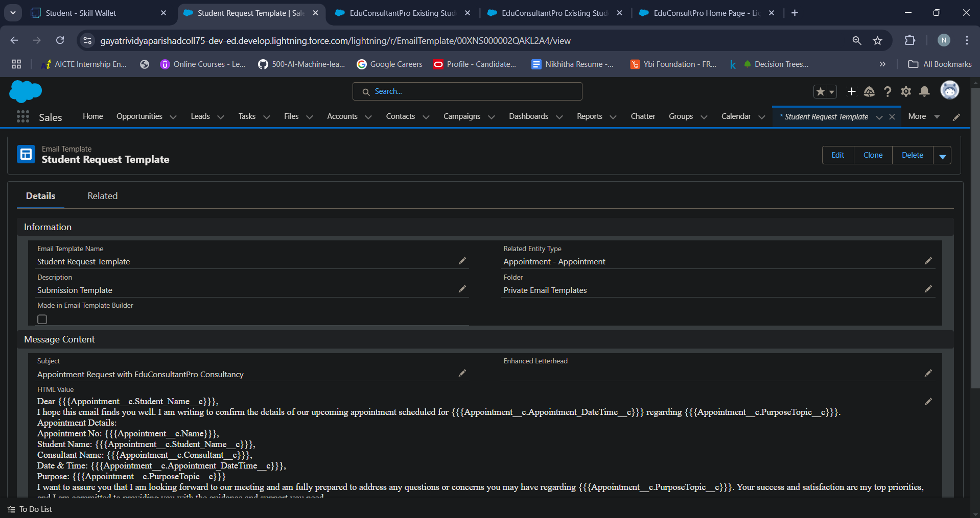

**Activity 2 - Create an Approval Process**

 From Setup, enter Approval in the Quick Find box, and then select Approval Processes.

* In Manage Approval Processes For, select Appointment.
* Click Create New Approval Process --> Use Jump Start Wizard.
* Configure the approval process.
* Process Name - Appointment Approval, Under Select Approver, Select Manager for the option : “Automatically assign an approver using a standard or custom hierarchy field.”
* Click next and “Next Automated Approver Determined By” --> Select Manager.
* From Record Editability Properties --> Click on Administrators OR the currently assigned approver can edit records during the approval process.
* Save the approval process.
* Click View Approval Process Detail Page.
* Under Initial Submission Actions, click Add New --> Field Update, and configure it with these values.
* click Add New --> Email Alert, and configure it with these values.

Description : Submission Email Alert

Unique Name : Auto Populates

Email Template : Submission Template

Recipient Type : Select your Name

* Repeat the Steps 10 - 11 for Final Approval and Final Rejection actions.

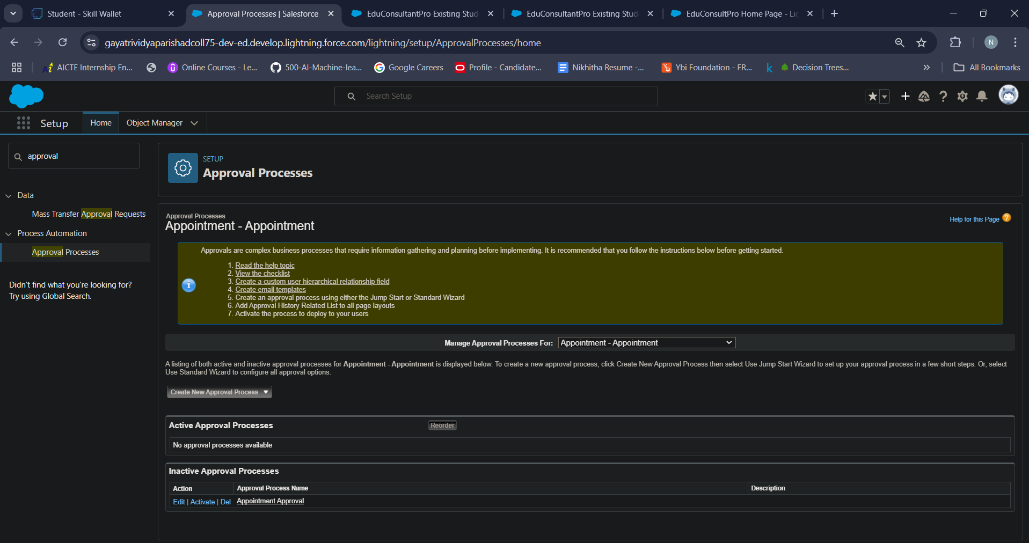

**Milestone 6: Create a Record Triggered Flow**

In Salesforce, a record-triggered flow is a type of automation that triggers when a specific action is performed on a record, such as creating, updating, or deleting it. Record-triggered flows are built using Salesforce Flow, allowing you to automate complex business processes and enforce consistency in data handling without needing to write custom code.

**Activity 1- Configure the Start Element**

* From Setup, enter Flows in the Quick Find box, then select Flows.
* Click New Flow.
* Select Record-Triggered Flow.
* Click Create. The Configure Start window opens.
* For Object, select Appointment.
* For Trigger the Flow When, select A record is created. The flow will look like this:

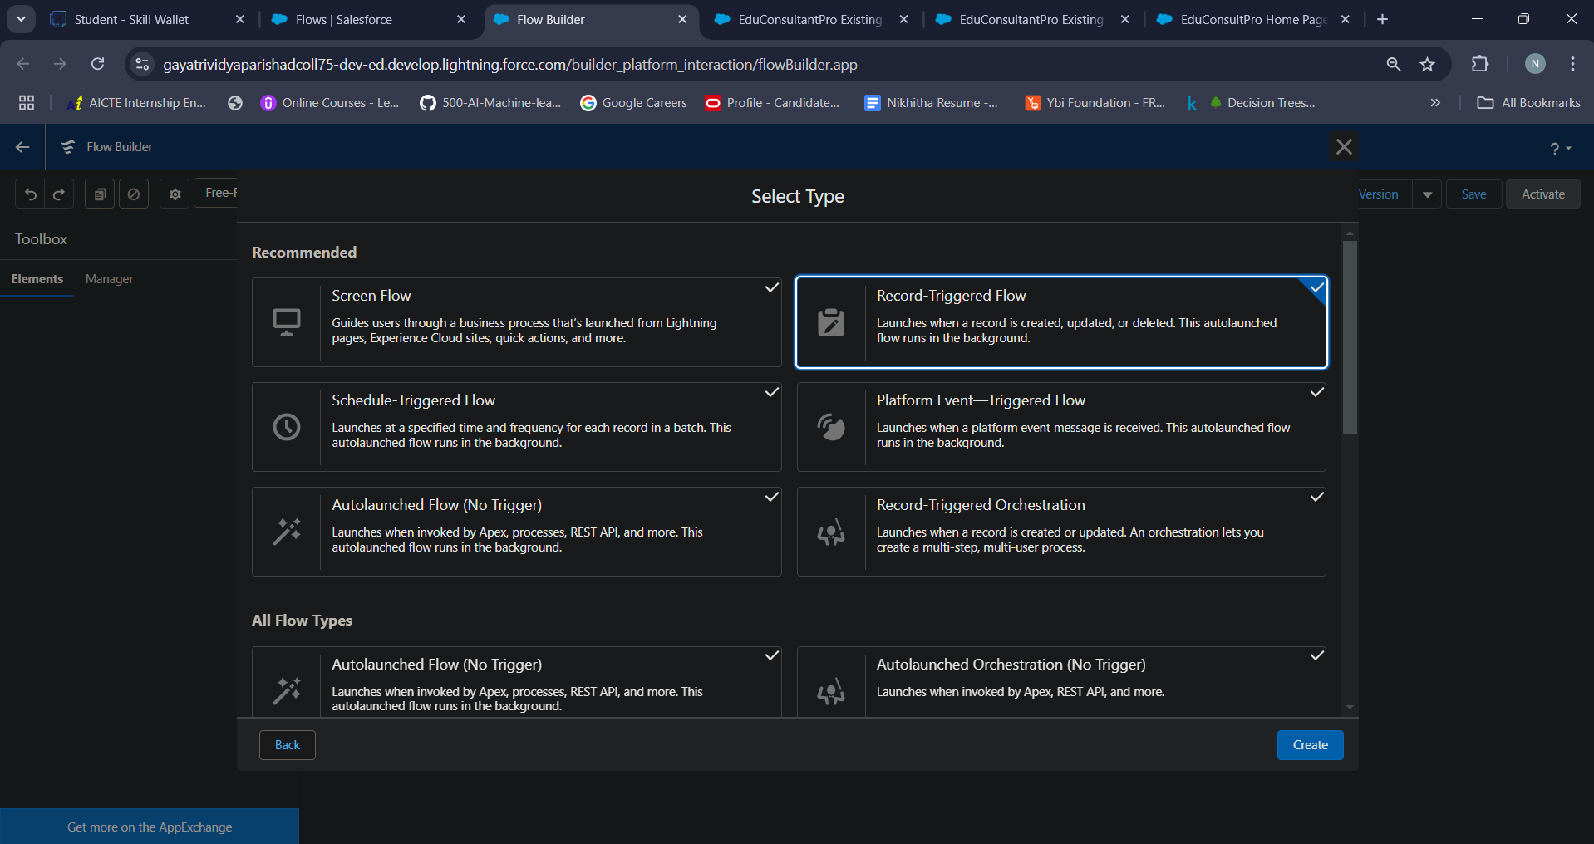

**Activity 2 - Add an Action Element**

* Add an Action element after the Start Element and Select the Submit for approval action, label it as “Approval SubFlow”.
* Set the RecordId to “{!$Record.Id}”.
* Save the Flow, label it as "EduConsultPro Approval Flow and Click on Activate.

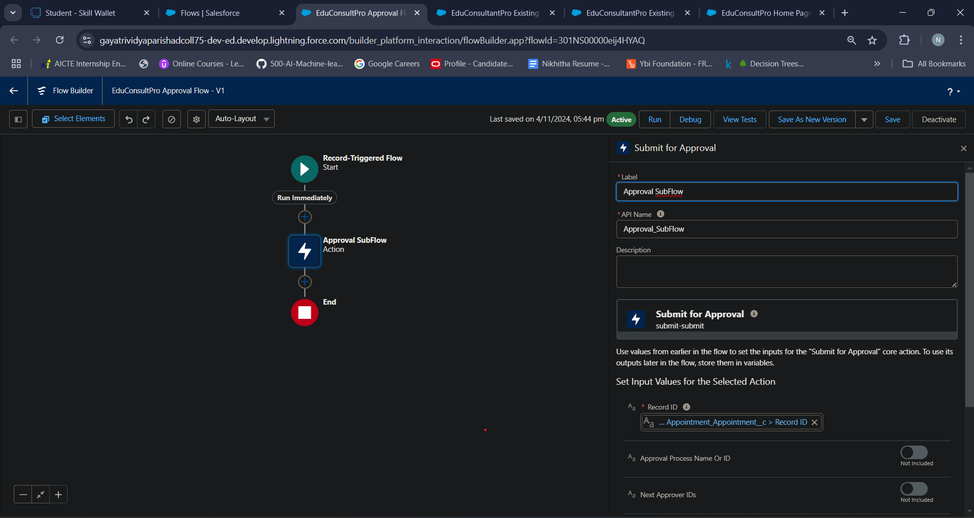

**Milestone 7: Create a ScreenFlow for Existing Student to Book an Appointment**

**Activity 1: Add Screen Element**

* From Setup, enter Flow Builder in quick find, select new flow ? ScreenFlow.
* Add a Screen element.
* In the Screen Properties pane, for Label, enter “Get Student Info”.
* Add two Text components from the left side panel. Give the Label’s as follows:
* 1st Text Component Label : Enter Student Name
* 2nd Text Component Label : Enter Student Email
* Click on Done.

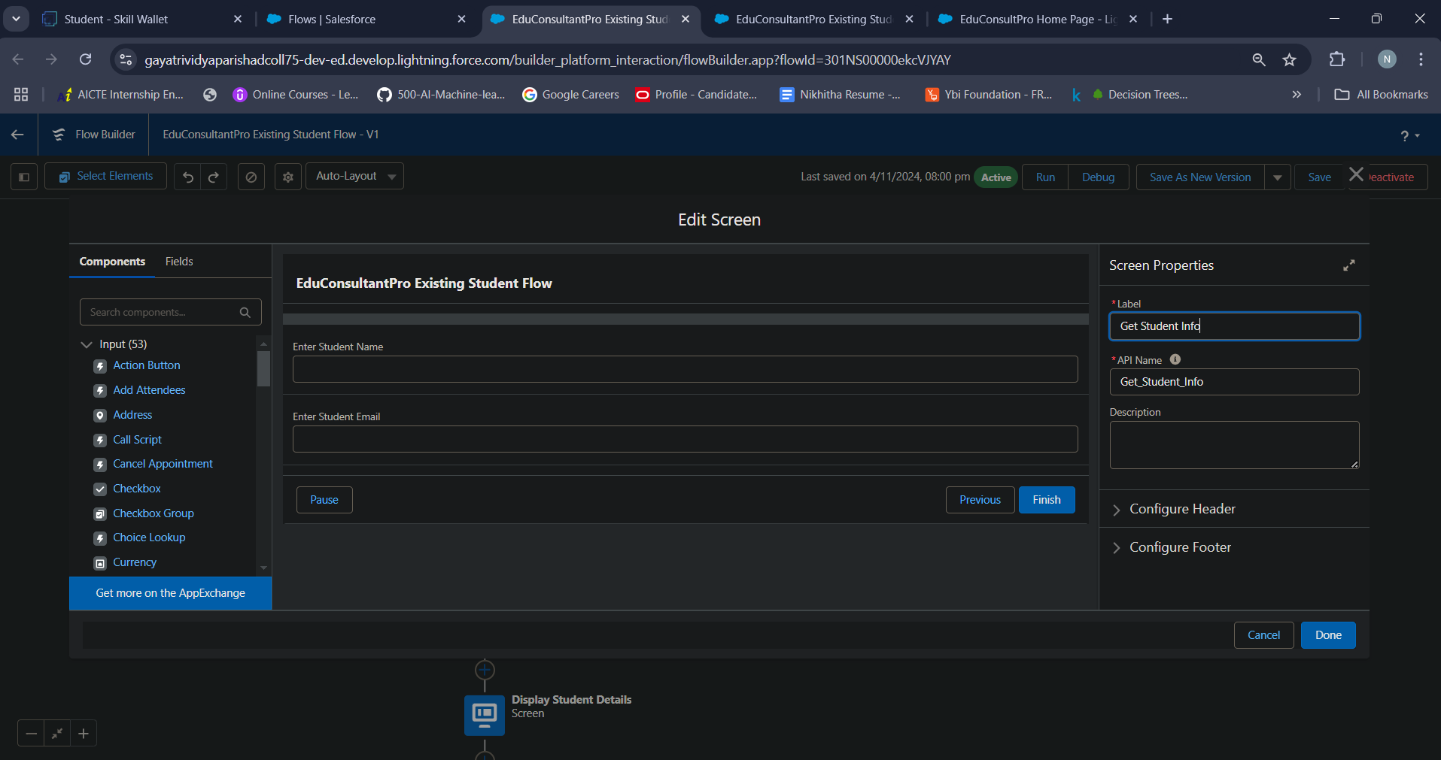

**Activity 2: Add GET Record Element**

* Add a GET Record Element after Decision Element, under the IELTS path and label it as “Get Rec”.
* Select Object : Student

Condition Requirement : All Conditions are Met(AND)

Field : Student Name

Operator : Equals

Value : {!Enter_Student_Name}

Field : Email__c

Operator : Equals

Value : {!Enter_Student_Email}

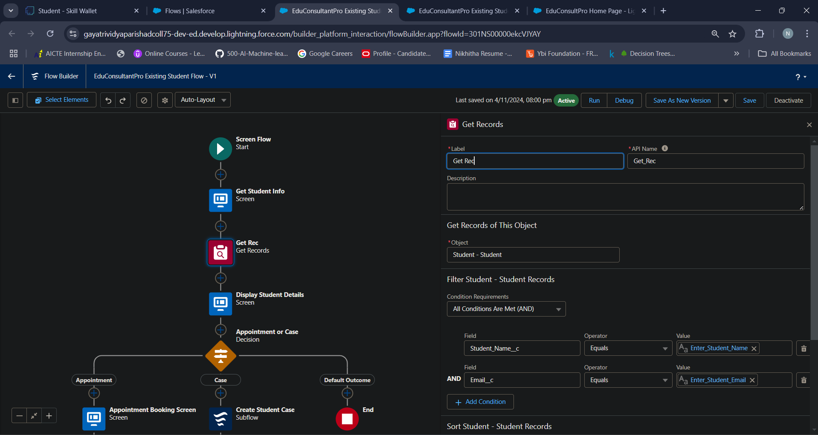

**Activity 3 - Add Decision Element**

* Add a Decision Element after Select Display Student Details Element, label it as “Appointment or Case”.
* Under outcome label it as “Appointment” and write the condition such as below:

Resource : {!How_may_I_Help_you}

Operator : Equals

Value : {!Book_an_Appointment}

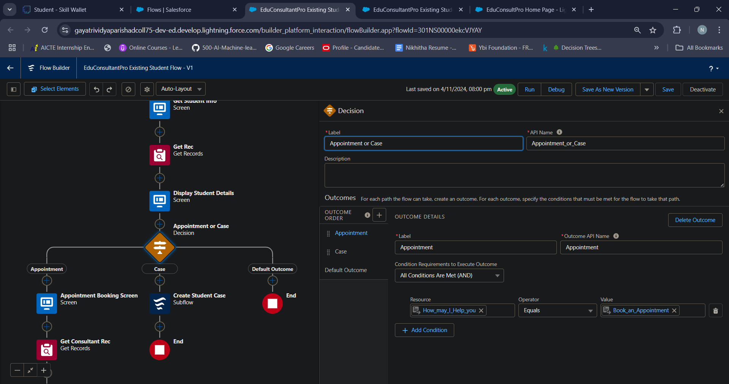

**Activity 3 - Add Screen Element**

* Add a Screen element after the Decision Element, on the Appointment path and label it as “Appointment Booking Screen".
* Click on Fields, click on the record variable input and create a new Resource (AppointmentRecordRes) to display all the fields which are in the Appointment object.
* Drag all the fields which are needed to add on the screen inorder to collect the student information.
* Click on Done.

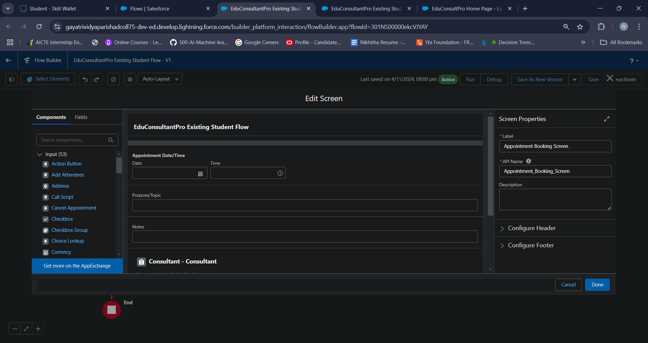

**Activity 4 - Add GET Record Element**

* Add a GET Record Element after Decision Element, under the Appointment path and label it as “Get Consultant Rec”.

Select Object : Consultant

Condition Requirement : All Conditions are Met(AND)

Field : Name

Operator : Equals

Value : {!AppointmentRecordRes.Consultant_Name__c}

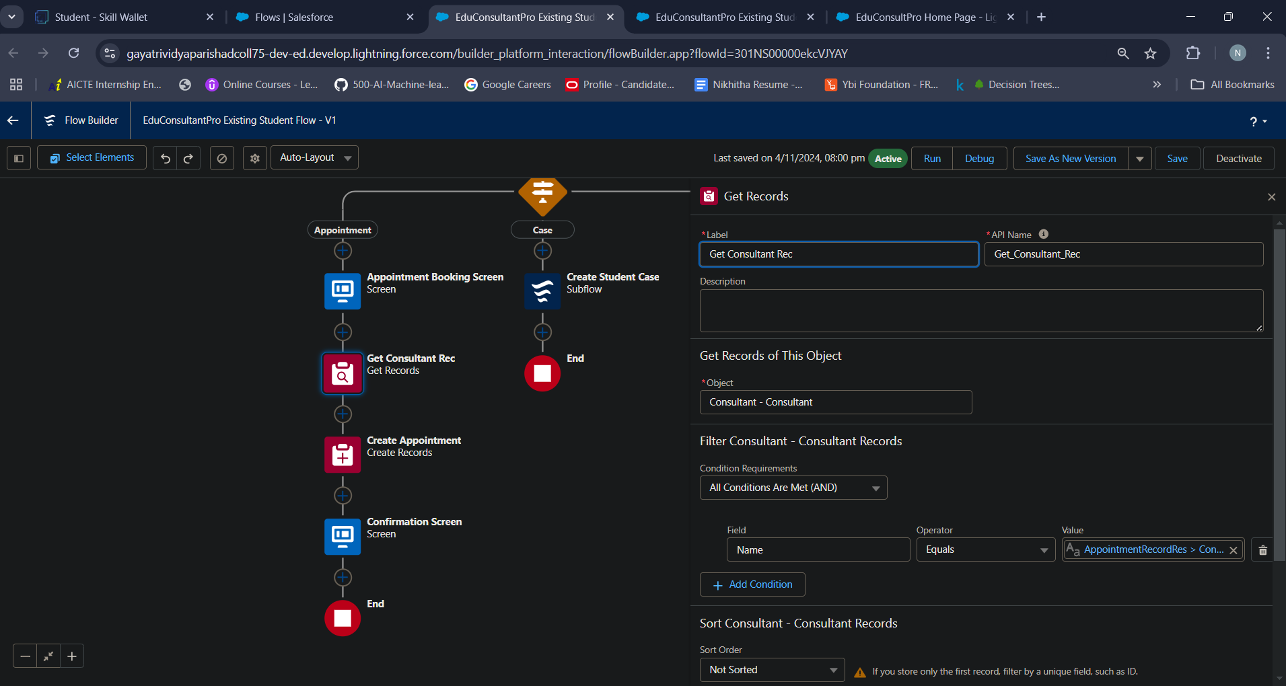

**Activity 5 - Create Appointment Record using Create Records Element**

* Add a Create element after the Get Consultant Rec element and label it as “Create Appointment”.
* Select “one” under How many records to Create, and select “Use separate resources, and literal values” under How to Set the record fields.

Select Object : Appointment

Field : Appointment_DateTime__c

Value : {!AppointmentRecordRes.Appointment_DateTime__c}

Field : Consultant__c

Value : {!Get_Consultant_Rec.Id}

Field : Notes__c

Value : {!AppointmentRecordRes.Notes__c}

Field : PurposeTopic__c

Value : {!AppointmentRecordRes.PurposeTopic__c}

Field : Student_Name__c

Value : {!Get_Rec.Id}

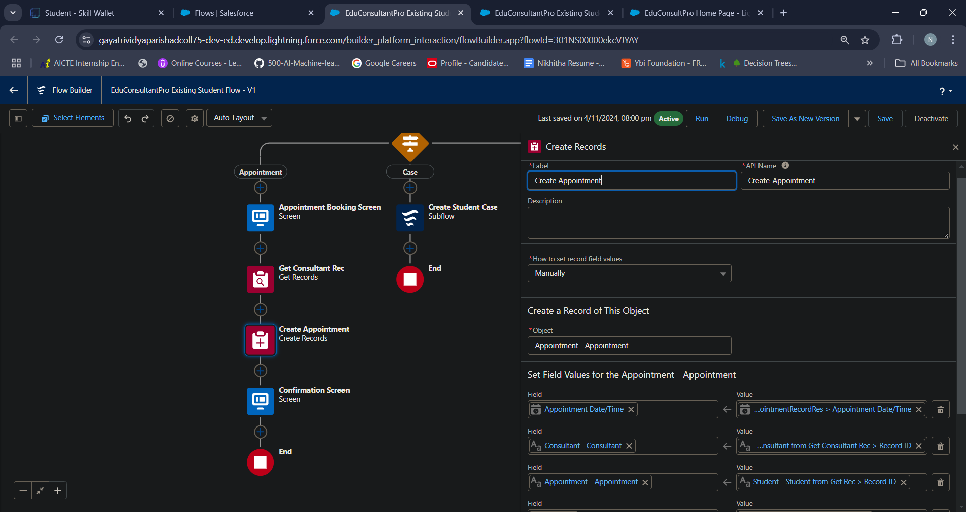

**Activity 6 - Add Screen Element**

* Add a Screen Element after the Send Email to Student Action Element, label it as “Confirmation Screen”.
* From the left side panel search for the Display text component and drag it to the main panel, label it as “Appointment_Confirmation”.
* Paste the below in the Resource picker box.

Consultant Name : {!Get_Consultant_Rec.Name},

Date & Time : {!AppointmentRecordRes.Appointment_DateTime__c},

Notes : {!AppointmentRecordRes.Notes__c},

* Click done

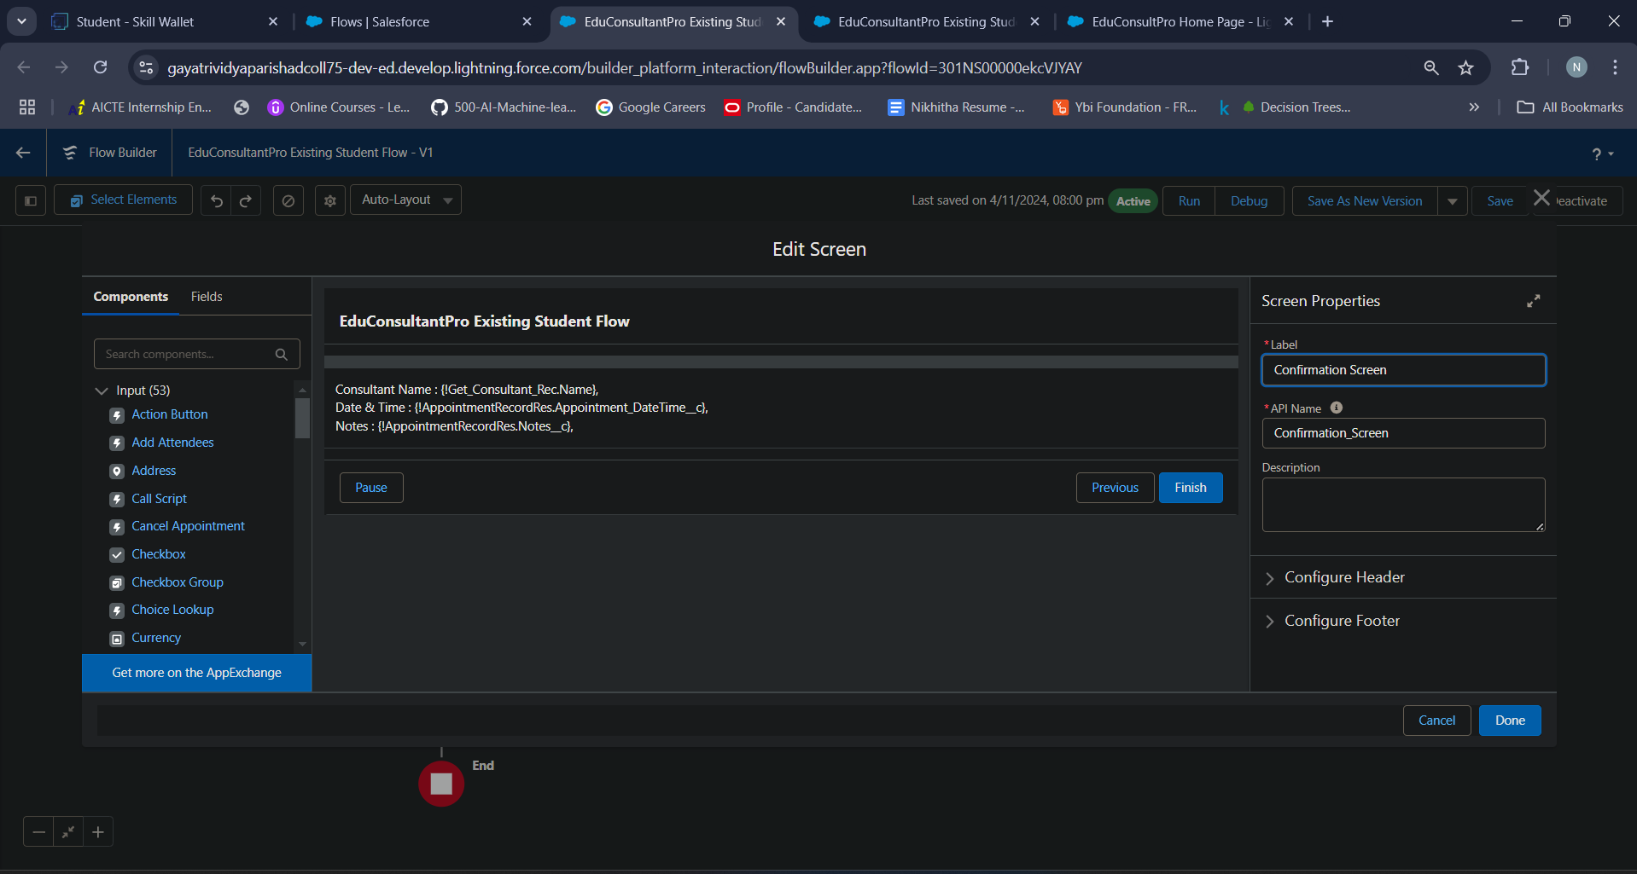

**Activity 7 - Add an SubFlow Element**

* Add a subflow element after the Decision Element, on the Case path and search and Select for “Create a Case”, label it as “Create Student Case”.
* Save the flow and label it as “EduConsultantPro Existing Student Flow”, you can use the below image for reference.

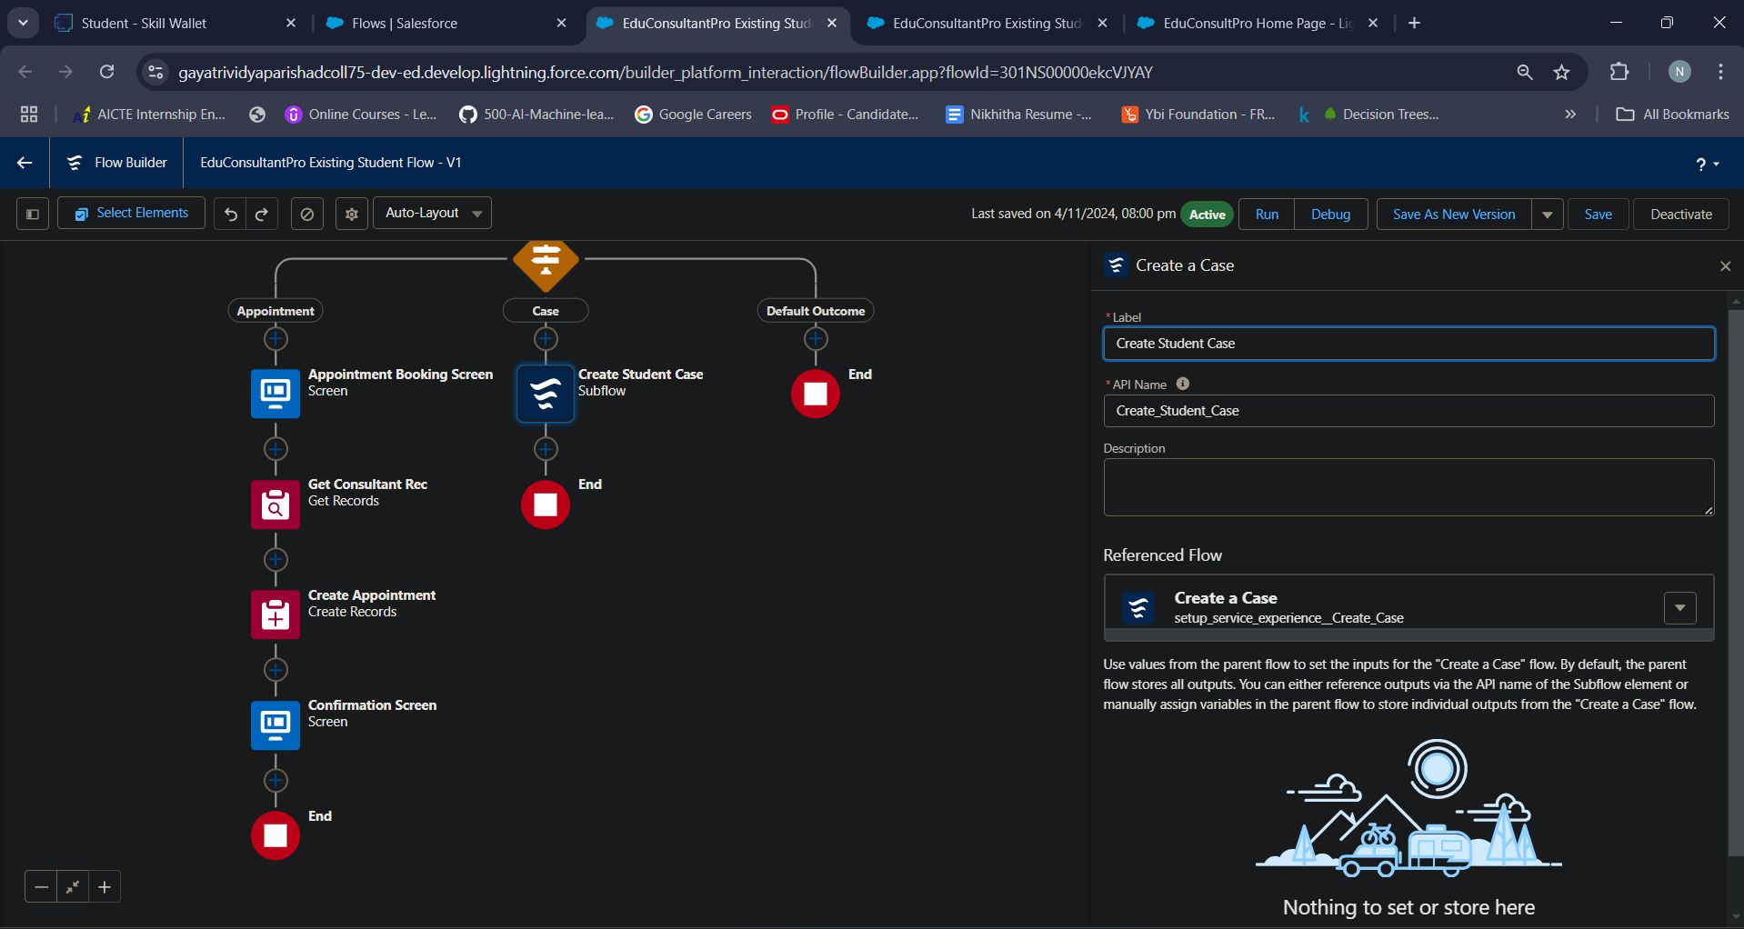

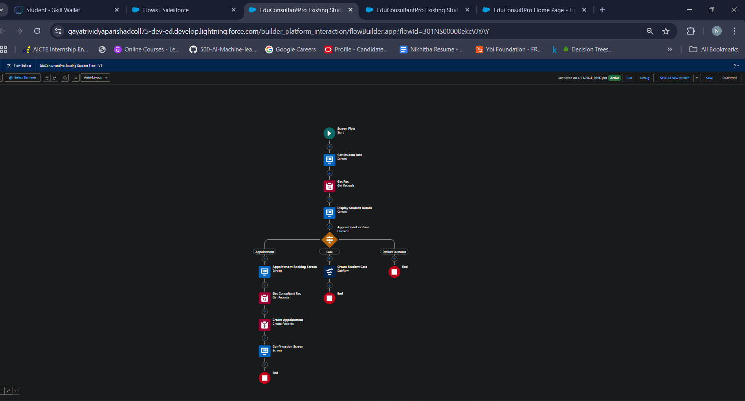

**Milestone 8: Create a ScreenFlow to Combine all the flows at one place**

**Activity 1- Add Screen Element**

* Add a Screen Element and label it as Welcome Screen.
* From the left side panel search for the Display text component and drag it to the main panel, label it as “SuccessMessage”.
* Paste the given text in the Resource picker box.
* Click done

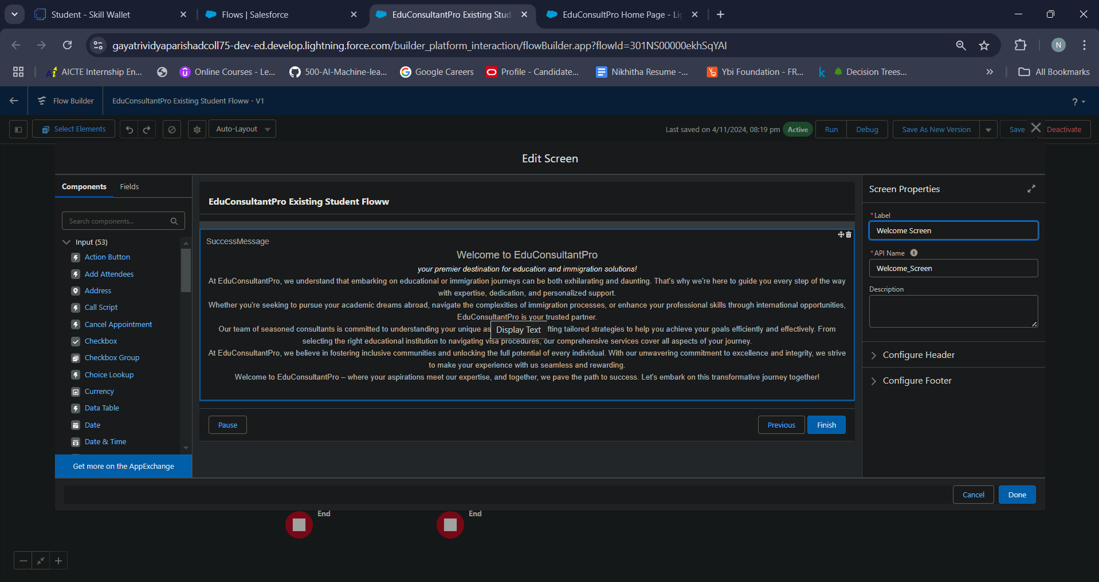

**Activity 2 - Add Screen Element**

* Add a Screen Element after the Welcome Screen Element, label it as “Existing or New Student Confirmation Screen”.
* Add a radio button component from the left side panel,

label : Are you a Existing Student

* Click on Add Choice --> type “Yes” in the input field --> click Create Yes choice.
* Repeat step 3 and create an “No” choice resource.
* Click done

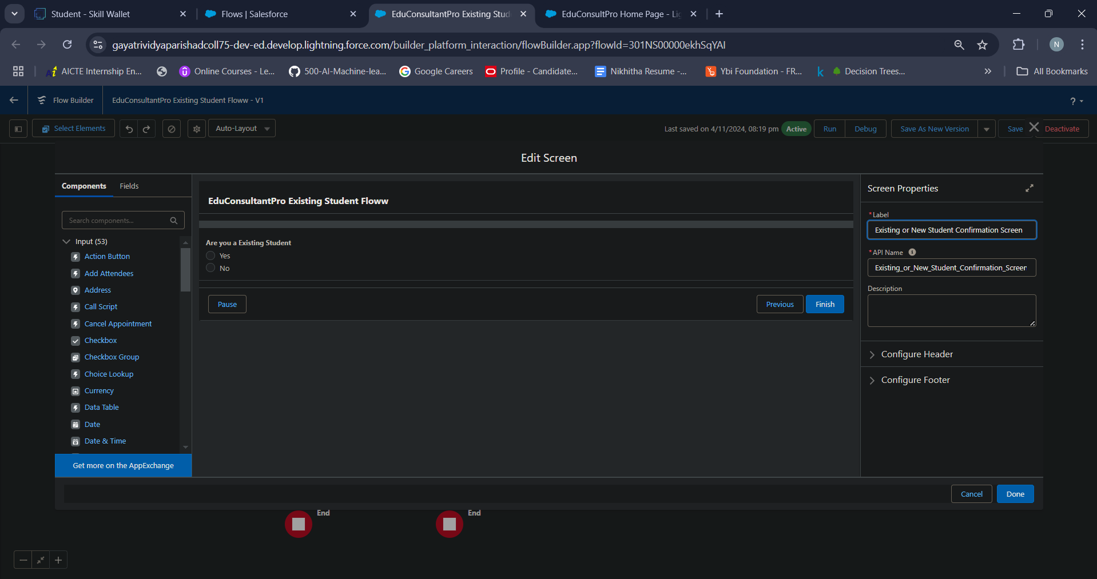

**Activity 3 - Add Decision Element**

* Add a Decision Element after Existing or New Student Confirmation Screen Element, label it as “Decision 1”.
* Under outcome label it as “If Existing Student” and write the condition such as below:

Resource : {!Are_you_a_Existing_Student}

Operator : Equal

Value : {!Yes}

* Click on the “+” icon and Repeat step 2 for No options mentioned.

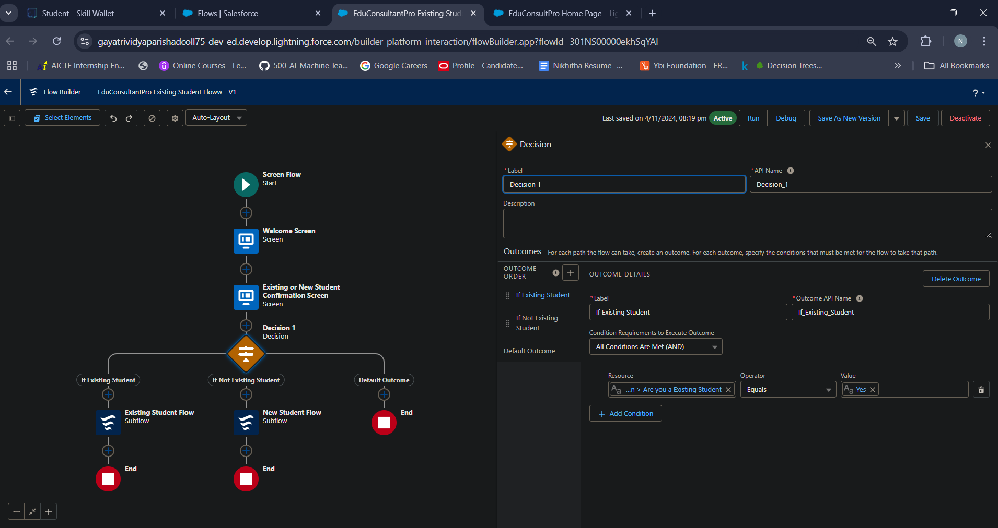

**Activity 4 - Add an SubFlow Element**

* Add a subflow element after the Decision 1 Element on the if Existing Student path and search and Select for “EduConsultantPro Existing Student Flow '', label it as “Existing Student Flow”.
* Save the flow and label it as “EduConsultantPro Existing Student Flow”.
* Click done

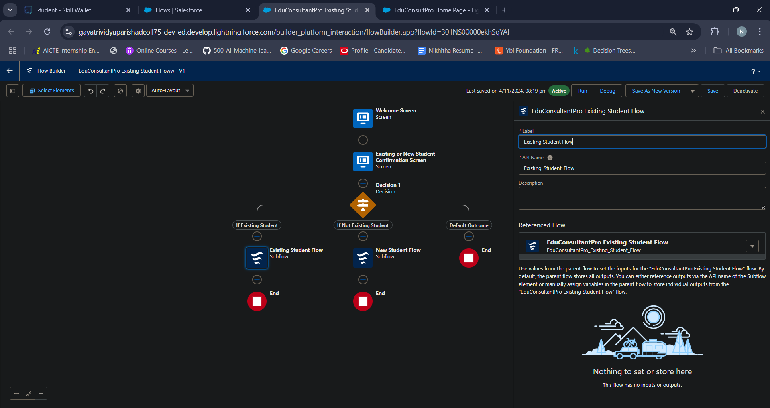

**Activity 5 - Add an SubFlow Element**

* Add a subflow element after the Decision 1 Element on the if Not an Existing Student path and search and Select for “EduConsultantPro Student Flow '', label it as “New Student Flow
* Save the flow and label it as “EduConsultantPro Existing Student Flow”.
* Click Done.
* Save the flow and label it as “EduConsultPro Flow”, you can use the below image for reference.

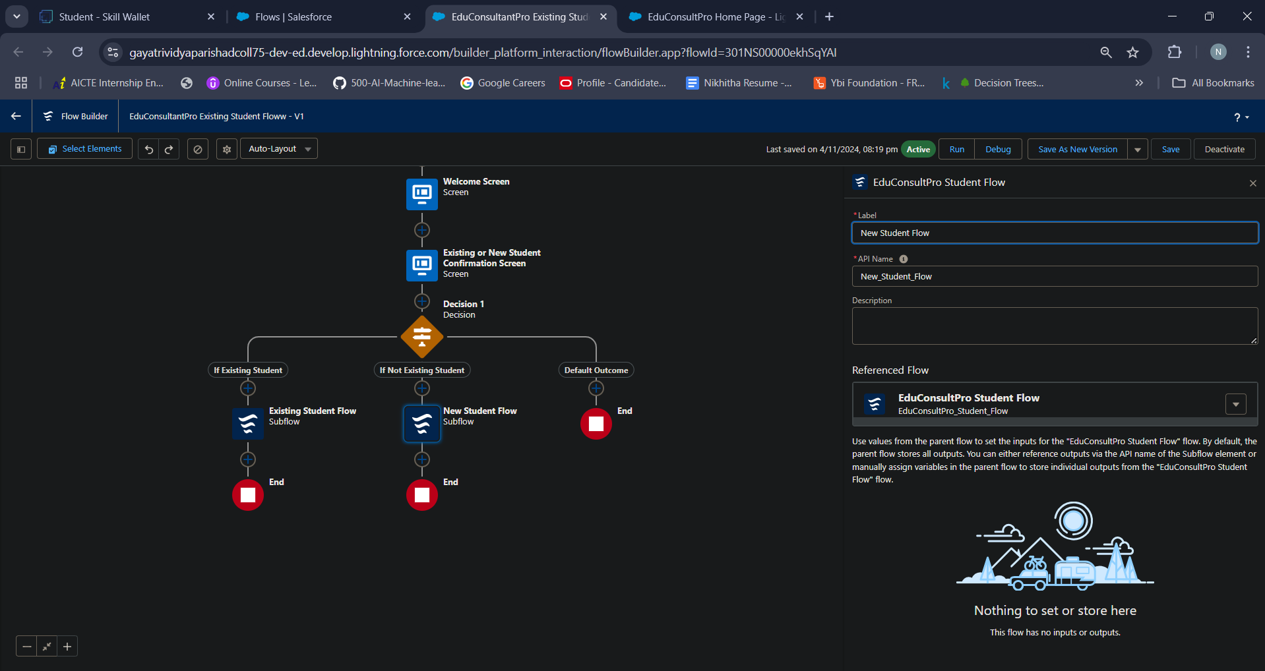

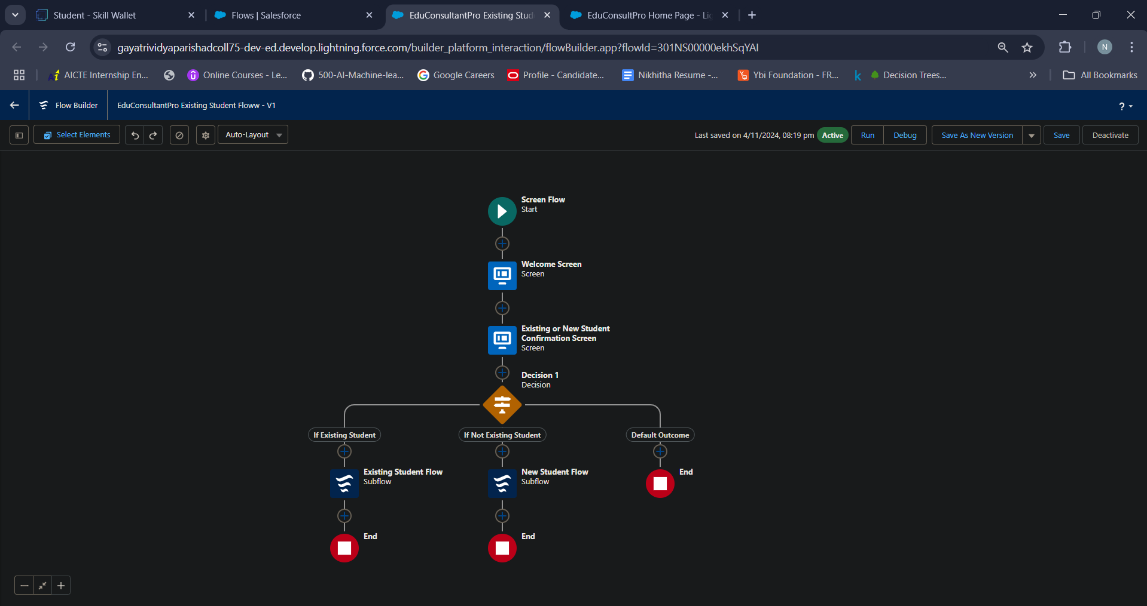

**Milestone 9: Create a lightning app page**

A Lightning App in Salesforce is an application built on the Salesforce Lightning Experience framework, which provides a modern, user-friendly interface for Salesforce users. Lightning Apps are part of the Salesforce Lightning platform, designed to improve productivity, usability, and flexibility by offering dynamic, customizable, and responsive applications.

Building a Lightning App in Salesforce

* Open App Builder:

Go to Setup and search for App Manager, then select New Lightning App to begin creating a custom Lightning App.

* Define App Details:

Enter the app’s name, description, branding (logo and colors), and other details to set the app’s identity.

* Configure Navigation and Utility Bar:

Choose the objects, tabs, and utilities to add to the app, making it easier for users to navigate and access frequently-used tools.

* Add Components:

Drag and drop base and custom components onto the app’s pages. Configure each component’s settings, visibility, and layout based on the needs of different user profiles.

* Assign to User Profiles:

Decide which users should have access to the app by assigning it to specific profiles or permission sets.

* Preview and Publish:

Test the app’s functionality and layout in preview mode. Once satisfied, publish the app for users to access.

**Activity 1: Create a lightning app page**

* From Setup, enter App Builder in the Quick Find box, then click Lightning App Builder.
* Click New, select Home Page, then click Next.
* Step through the wizard and name the page “EduConsultPro Home Page”, select the Standard Home Page template, and then click Done.
* Drag the Flow component to the top-right region.
* Search for the “EduConsultantPro Flow” and click Save.
* Click Activate, Click App and Profile, then click Assign to Apps and Profiles.
* Select the Sales app, then click Next.
* Scroll down the list of profiles and select System Administrator, then click Next.
* Review the assignment, and then click Save.



